CONTACT: Dave Hubbard FOR IMMEDIATE RELEASE
770-271-0048
dhubbard@protech1.com
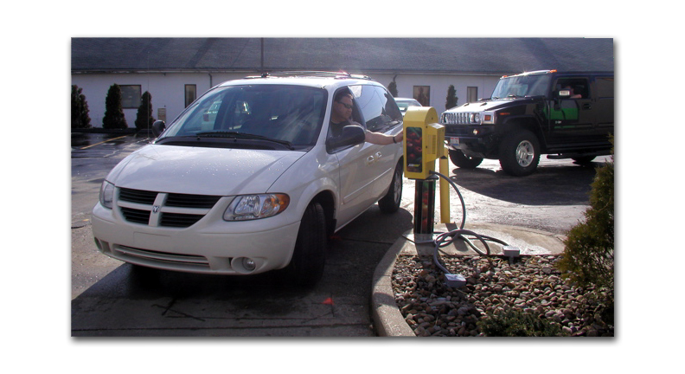
Pictured here:
Customer uses Pro-Tech Kiosks’ drive-thru kiosk at Subway in Mentor, OH

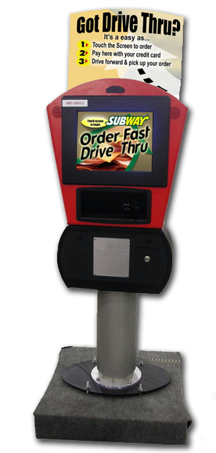

Pictured here: Pro-Tech Kiosks drive-thru unit customized for Subway

