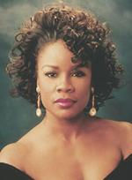
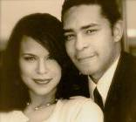
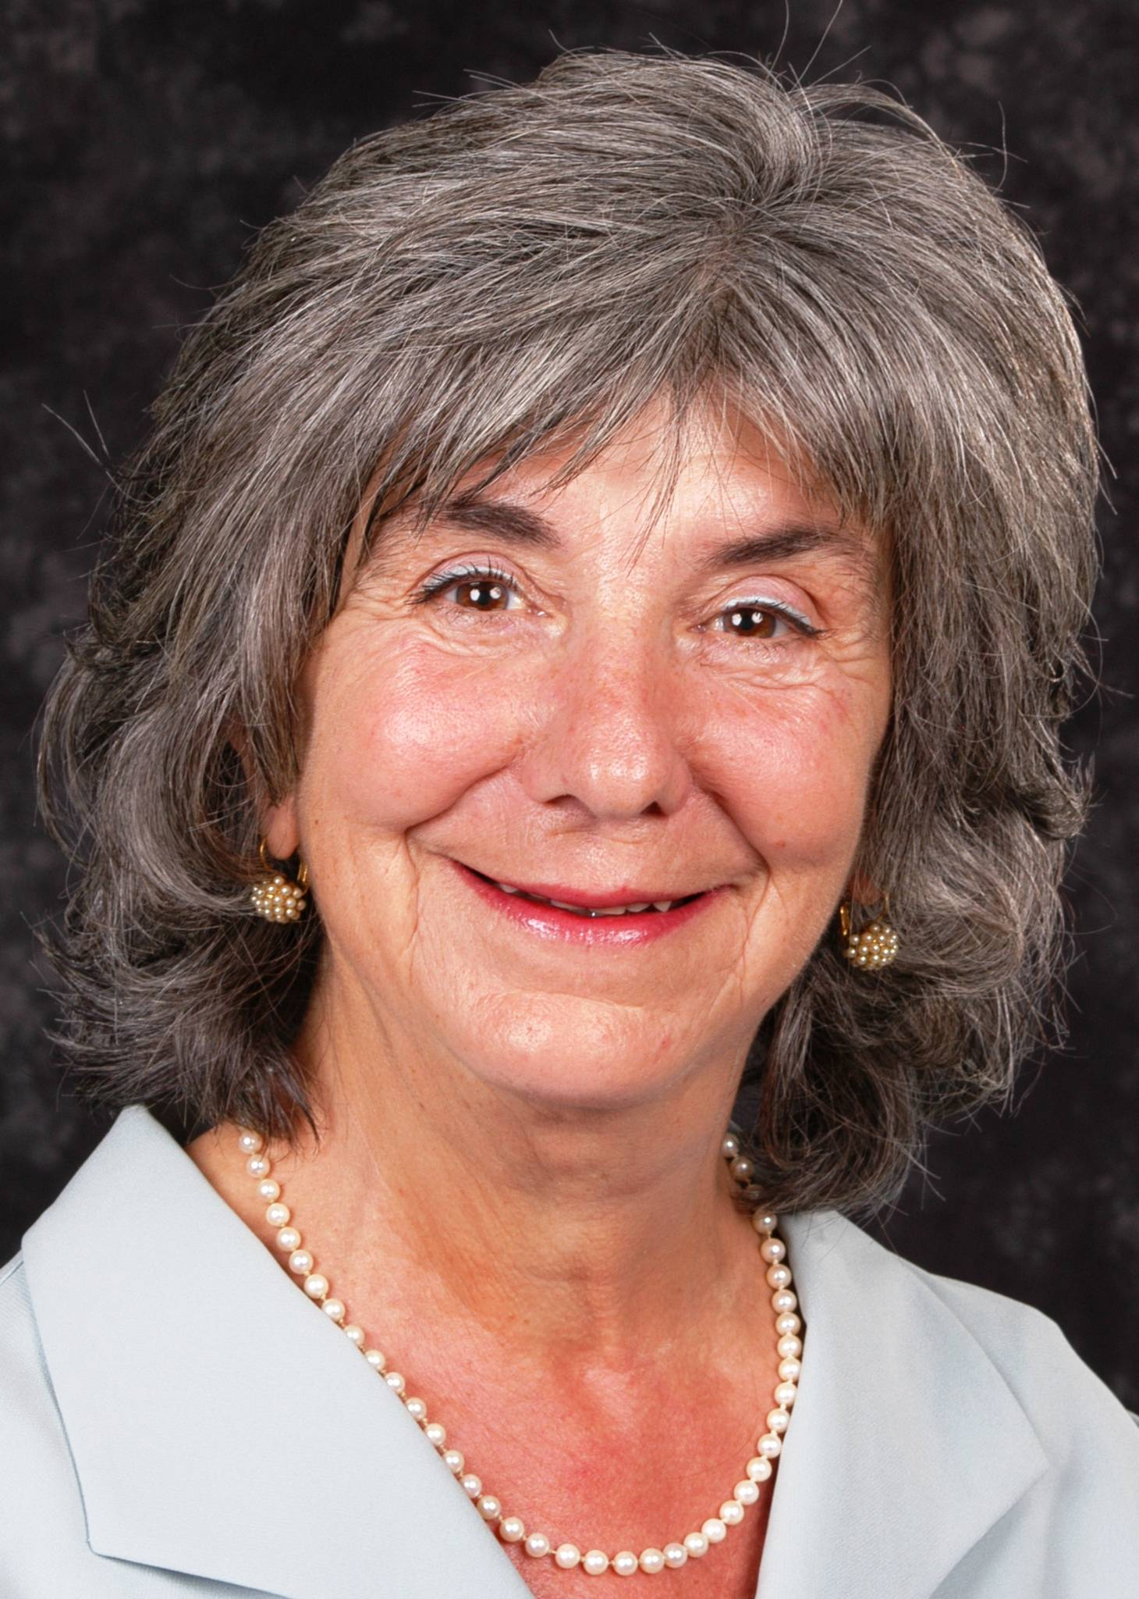
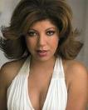
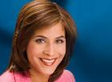
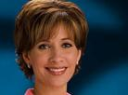

Denyce Graves

Internationally famous, American mezzo soprano.
“If the human voice has the power to move you – you will be touched by Denyce Graves."
-The Atlanta Journal-Constitution

Baby Shower for
Drs. Susan & Brian EVANS
Judy Bencivengo, M.A.

Child Care Resource Coordinator for UCLA Early Care and Education Center, will speak about “The Power of Self-Esteem”
Sunda Croonquist

One of the most popular female comics at The Laugh Factory. Her television appearances include VH1 and Comedy Central
Featuring Leslie Sykes, the weekend co-anchor of the ABC channel 7
"Eyewitness News"
Also featuring Jovana Lara, the co-anchor of ABC channel 7's midday newscast

