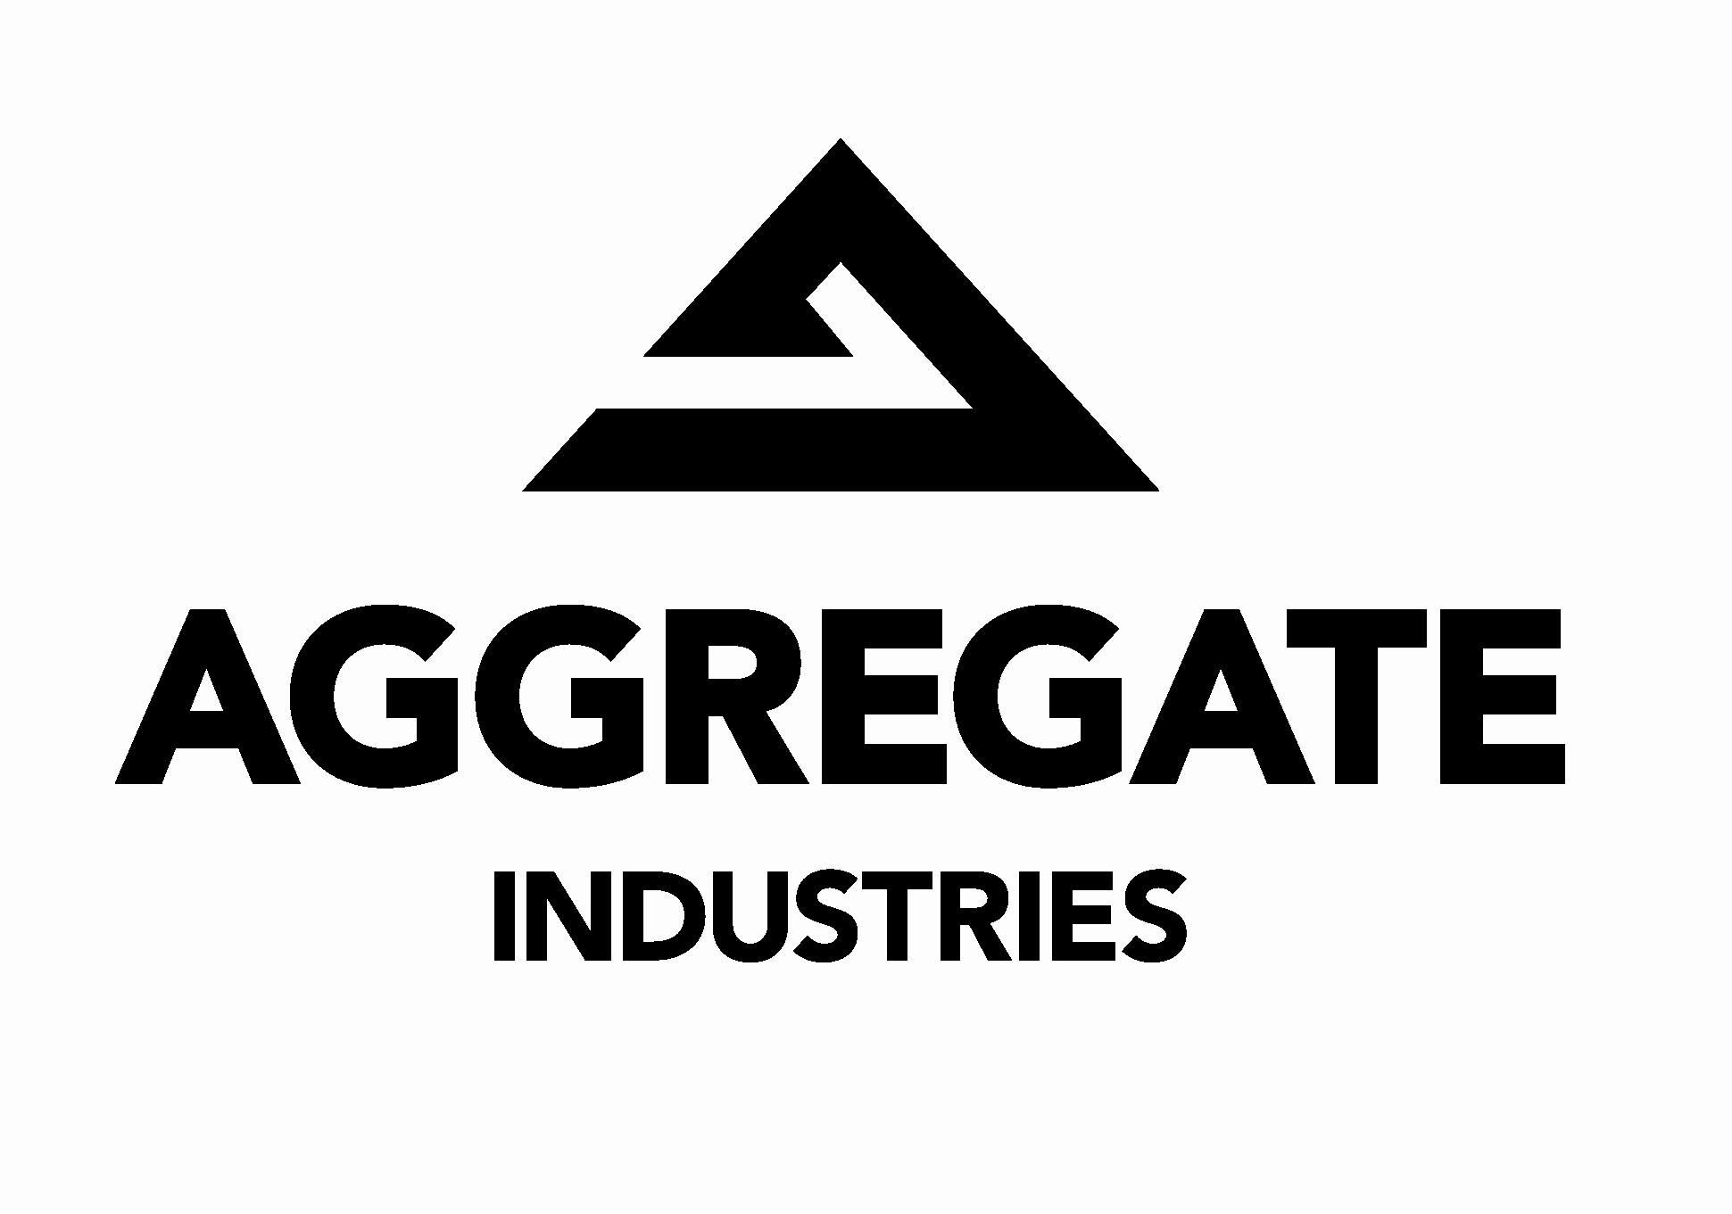



Contact: Janice Richards
Manager
Communications
Holcim (US) Inc.
Waltham, MA 02154
781-647-2503

Nicole Jarry
Director
Corporate Communications
St. Lawrence Cement
Mount Royal, Quebec
H3R 1H1
514-340-1555

Joe Merlino
Manager
Marketing and Communications
Aggregate Industries
Rockville, MD
20850
301-284-3615

FOR IMMEDIATE RELEASE

Holcim Awards:
Building New Perspectives for Our Future
Two million dollar competition for sustainable construction projects

Waltham MA June 1, 2007 –The second Holcim Awards competition to promote sustainable construction worldwide is now open. The Holcim Awards are an international competition for projects that embody approaches to meet the present-day needs for housing and infrastructure without compromising the ability of future generations to meet their own needs in times to come.

The Holcim Awards are supported in North America by the Holcim Ltd group companies Holcim (US) Inc., St. Lawrence Cement, and Aggregate Industries.

Entries in the competition can be submitted until February 29, 2008 at www.holcimawards.org. The prize money for the five regional competitions and the global awards totals USD two million. The Awards are an initiative of the Swiss-based Holcim Foundation to encourage and inspire a built environment that goes beyond convention to address the challenges of sustainability.

The global competition showcases sustainable responses to technological, environmental, socioeconomic and cultural issues affecting contemporary building and construction. The Awards are open to anyone involved with projects in the area of sustainable construction – architects, planners, engineers, or project owners. All building projects are eligible for the competition if construction had not started before June 1 of this year. The first phase of the competition will select regional winners in 2008 that will automatically qualify for the global competition to be held in 2009.

In addition to construction projects at an advanced stage of design, the Awards competition seeks visions and ideas at a conceptual level. This special category is open for professionals younger than 35 years of age.

Measuring up to target issues for sustainable construction
Submissions in the Awards competition are evaluated by independent juries in five regions of the world, using a five-point definition of sustainable construction. These so-called “target issues” serve as a yardstick to measure the degree to which a building contributes to sustainable development. Three of the five target issues align with the primary goals of the Rio Agenda: balanced environmental, social, and economic performance. One target issue applies specifically to building: the creation of good buildings, neighborhoods, towns, and cities. A further target issue recognizes the need for significant advancements that can be applied on a broad scale: Ecological quality and energy conservation; economic performance and compatibility; ethical standards and social equity; contextual and aesthetic impact; and quantum change and transferability.

The juries will be headed by internationally renowned architects and academics: Harry Gugger, architect and author, Switzerland (region of Europe), Adèle Naude Santos, Dean of Architecture, Massachusetts Institute of Technology, USA (North America), José Luis Cortés, Dean of Architecture, Universidad Iberoamericana, Mexico (Latin America), Joe Addo, architect, Ghana (Africa Middle East), and Ashok Lall, architect, India (Asia Pacific). Charles Correa, architect, India, will chair the jury of the global Holcim Awards competition. A full list of all members of each jury is available on www.holcimawards.org, where comprehensive information on the competition is available and entries can be submitted on-line in English only.

Supported by world-renowned technical universities
To carry out the competition the Holcim Foundation works closely with leading technical universities: the Swiss Federal Institute of Technology (ETH Zurich), Switzerland; the Massachusetts Institute of Technology (MIT) in Cambridge, USA; Tongji University (TJU) in Shanghai, China; Universidad Iberoamericana (UIA) in Mexico City, Mexico; and the University of the Witwatersrand (Wits) in Johannesburg, South Africa. These universities host the jury meeting in their regions. The Universidade de São Paulo (USP), Brazil is an associated university of the Foundation.

46 prize winning projects in the first competition
The Holcim Awards competition 2005/06 attracted more than 3,000 submissions from 120 countries. Joint winners of the global Awards Gold were an urban integration project in Caracas, Venezuela, and the design for a new main railway station in Stuttgart, Germany. The global Awards Silver went to a regional masterplan and renewal strategy for the Mulini Valley near Amalfi, Italy and Bronze to a low-cost housing and urban renewal project in Montreal, Canada. Details about all 46 prize-winning projects and the Holcim Foundation are available at www.holcimfoundation.org.

The Holcim Awards competition is an initiative of the Holcim Foundation for Sustainable Construction, which is supported by Holcim Ltd but is independent of its commercial interests. Holcim Ltd is one of the world's leading suppliers of cement and aggregates (crushed stone, gravel and sand) as well as further activities such as ready-mix concrete and asphalt including services. The Holcim Group holds majority and minority interests in more than 70 countries on all continents and employs almost 90,000 people.

Holcim (US) Inc. is a subsidiary of Holcim Ltd, and one of the nation’s leading manufacturers and suppliers of cement and mineral components. Holcim (US) has 2,400 employees and operates 14 manufacturing plants and over 70 distribution facilities in the United States.

St. Lawrence Cement, a company of the Holcim Group, is a leading producer and supplier of products and services for the construction industry, namely cement, concrete, aggregates and construction. The company operates in Canada and on the eastern seaboard of the United States, and employs a total of 3,200 people.

Aggregate Industries, a wholly-owned subsidiary of Holcim Ltd, is an environmentally responsible producer of high-quality aggregate-based construction materials in the United States and the United Kingdom. The company produces aggregates, ready-mixed concrete, concrete products and asphalt (and related contracting services) in seven regional businesses in the US.

###

