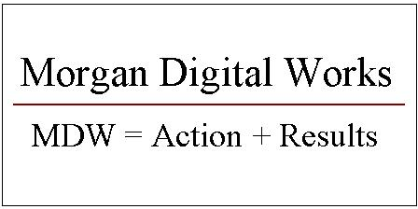
Morgan Digital Works
555 Bryant Street
PMB 287
Palo Alto, California 94301
USA

Voice 408 667-6054
Email info@morgandigitalworks.com
Web www.morgandigitalworks.com

FOR IMMEDIATE RELEASE

Morgan Digital Works Unveils its Plan to Develop a Commercial Website Promoting Greener Homes and Greener Wallets

Palo Alto, CA – July 16, 2007 – Morgan Digital Works (MDW), a product development consultancy that serves high-technology companies in Silicon Valley, announced today its plan to develop GreenForHomes.com, a commercial website dedicated to the promotion of residential green building products and services. The company is actively seeking corporate sponsors, with plans for a regional advertising campaign to kick-off the launch of the new website.

For the average homeowner who wants to reduce their environmental footprint and save money while saving the planet, GreenForHomes.com is a comprehensive, commercially-sponsored website that provides a great user experience while presenting customized green home improvement plans based on sound Return On Investment (ROI) criteria. ROI is realized in hard cash savings, taking into account both construction and operating costs. Unlike websites operated by state or local government agencies that offer generic suggestions or guidelines, this website will compile targeted commercial solutions for the homeowner based on their ability to invest in green building products and services.

“We’re redefining home improvement in terms of saving the planet and saving money. In order to do that, the homeowner must be given an opportunity to evaluate the financial benefits of various green building technologies available on the market today,” said Art Morgan, Technical Marketing Officer at Morgan Digital Works. “Clearly the biggest challenge for homeowners is to make sense of the bewildering array of available green building solutions. This is where GreenForHomes.com will help with customized, step-by-step home improvement plans based on sound financial criteria. In addition, we’re pleased to say that the website will take full advantage of home specification data available from public Web sources such as real estate listings and satellite imagery. This will automate the home evaluation process by requiring a minimal amount of homeowner data entry and hassle. It’ll work like magic!”

More Information

For preliminary information about the GreenForHomes.com website, please visit http://www.GreenForHomes.com.

About Morgan Digital Works

With over a quarter century of combined experience in systems engineering, product marketing and product management, Morgan Digital Works is uniquely qualified to help companies address the recent challenges transforming the digital electronics industry. With the recent introduction of global environmental compliance legislation for electronic products, MDW has helped companies define and implement Design for Environment and Eco-Design development programs – building better products for a better environment.

# # #

