Pearl jewelry – necklaces, bracelets, earrings, rings and pendants, bridal pearl jewelry at
http://www.topearl.com/
Freshwater pearls, akoya pearls, Mabe pearls - http://www.topearl.com/
Pearl necklace jewelry at http://www.topearl.com/freshwater-pearl-necklaces-c-1.html
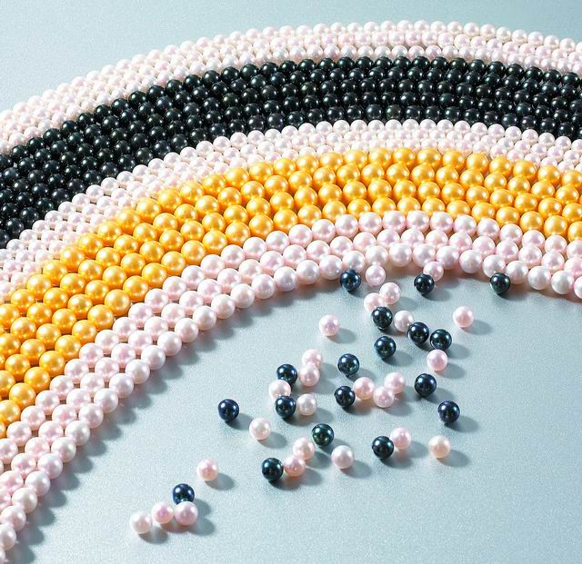 loose pearls -
http://www.topearl.com/loose-freshwater-pearls-c-27_36.html
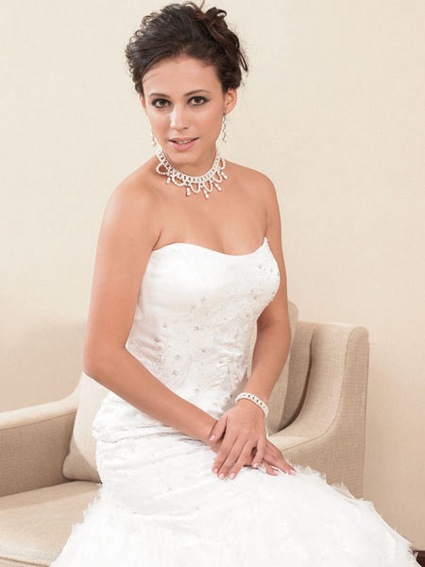 Bridal pealr jewelry at
http://www.topearl.com/bridal-bridesmaid-jewelry-c-136.html

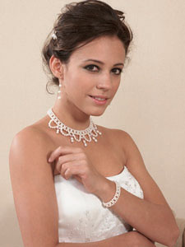 Freshwater pearl jewelry set for bridal occasion

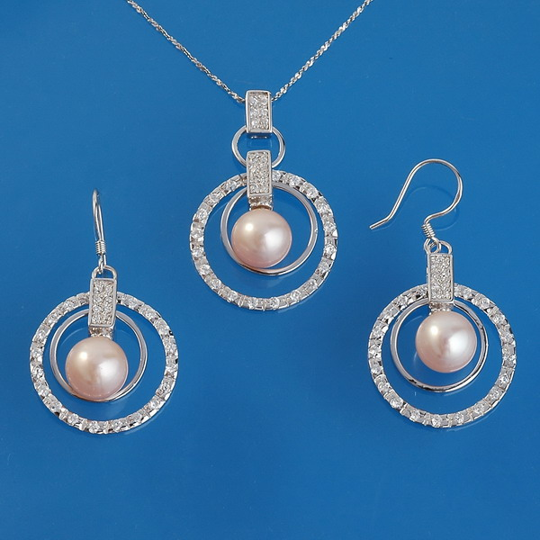 Stertling silver freshwater pearl pendant, earrings set
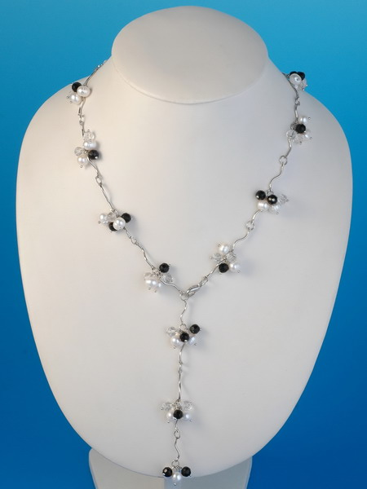 Freshwater pearl necklaces in
http://www.topearl.com/freshwater-pearl-necklaces-c-1.html

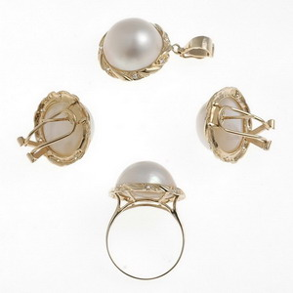 !4K gold Mabe pearl pendant, earrings, ring sets in
http://www.topearl.com/mabe-pearl-jewelry-c-32.html

