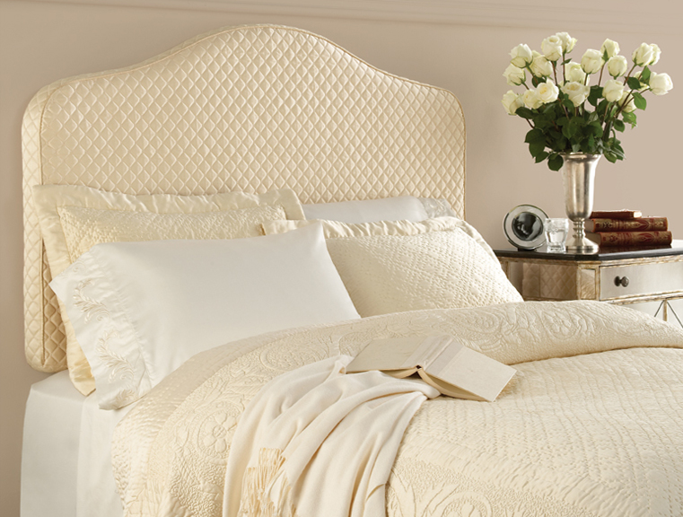

Sofia Matelassé – Ivory

BackDrop™ In For The Holidays
Affordable Upholstered Headboards Make Your Bed and Your Holiday Company Feel At Home
BackDrop™ is a new, revolutionary headboard collection that combines an upholstered slipcover with an inflatable inner air cushion. Our patent-pending fusion of style and comfort instantly transforms the look of a bedroom, with pricing between $79 for a twin and $129 for a King. The air-cushion design provides comfortable support when reading, watching TV or lounging in bed. The no-tools installation completes your bedroom makeover in less than 5 minutes.
• The complete set includes an upholstered slipcover, air cushion, electric pump, wall tabs
• The Camelback design is distinctive, and provides a classic feel to any bedroom
• The Sofia Matelassé fabric fills your bedroom with luxurious comfort
• BackDrop™ is backed by a 5-year unconditional replacement guarantee
• Fabric Type: 65% cotton, 35% polyester
So go ahead, let your friends and family BackDrop™ in for the holidays! With many styles and fabrics to choose from, BackDrop™ MakesYour Bed!
# # #
BackDrop™ upholstered headboards are made and distributed by Levinsohn Textile Company, Inc., a 65 year old family-owned business.. For more information on our product, visit the website at www.backdropheadboards.com or call 724-535-7787 for customer service.
For press inquiries, contact Lisa Rayner Tush at 404-803-0611.

