FOR IMMEDIATE RELEASE
Media Contact
Kaveh Samim
949-273-2422
info@farsmovie.com
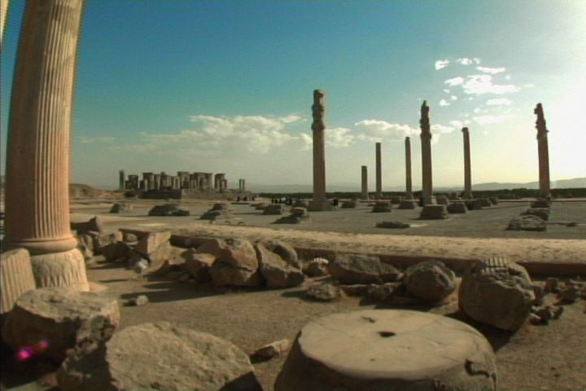

Historical Documentary Film “IRAN, The Forgotten Glory” released
Persian Culture and Identity Revealed
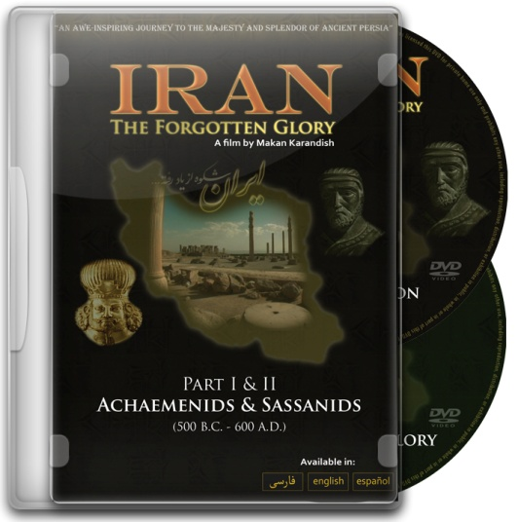
IRVINE, CA, March 26, 2009 – Coinciding with the arrival of the Persian New year, the much anticipated historical documentary film “IRAN the forgotten glory” directed by Makan Karandish and produced by Mystic Films Intl. was released this week in Los Angeles, California in 2 DVD’s in the languages of Persian, English, and Spanish. According to Makan Karandish, director of the film “This film has been in production for more than 5 years and was shot in over 60 locations throughout the province of FARS. It is an attempt to re-capture the glory of the ancient Persian empires and their influence on world history, art, and culture” The film’s total running time is 95 minutes and includes 2 episodes. The film was originally premiered in Oct. 2008 in the Bogota Film Festival. For more information visit www.farsmovie.com

About “IRAN, The Forgotten Glory”
Shot in over 60 locations in the province of FARS and 5 years in the making, “IRAN, The Forgotten Glory” is the first independent documentary film series taking the audience on a journey into the depths of ancient Persian civilization, capturing the majesty and the splendor of the Achaemenid and Sassanid empires and their influence on world history, religion, art and culture by revealing the ancient tales hidden in the ruins and reliefs which exist today as a testament to their legacy." For more info visit www.farsmovie.com
About Mystic Films Intl.
Established in 2003 in Irvine CA, Mystic Films Intl. is an independent film production company with the goal of creating enriching cultural films about Iranian history & culture and creating awareness of the rich Persian heritage throughout the world. For more info visit www.mysticfilms.com

