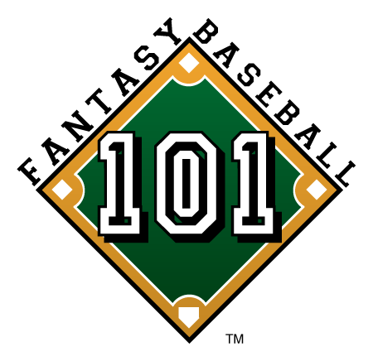

FOR IMMEDIATE RELEASE Media Contact:
Jeremy Muratore
310-793-6263
jmuratore@fantasybaseball101.com

March Madness Represents a Temporary Illness
That Strikes Millions of Americans

Key Symptoms Include Excessive Basketball Watching and Ignoring the Looming Start to the 2009 Fantasy Baseball Season, says Fantasy Baseball 101 LLC.

April 1, 2009 (ARLINGTON, VA) – With college basketball dominating the sports headlines for the next few weeks, Fantasy Baseball 101 LLC (FB 101) co-founders Evan Rosen and Russell Sandman want to take a minute to remind you to get your head in the game and visit www.fantasybaseball101.com – there are only four more days to the start of the 2009 MLB season.

“I enjoy March Madness, but now is the time to research player rankings, identify sleepers, tweak your draft strategy, and review injury reports. If you don’t prepare for your draft you could be putting your entire fantasy season in peril,” says Rosen.

Rosen and Sandman have over 20 years of fantasy baseball experience apiece. The childhood friends began playing in 1988 as fifth graders in what may be the world’s first ten-and-under Fantasy Baseball League.

Over the past couple decades they have honed their skills with impressive results against amateurs and professionals alike. In 2008, Rosen and Sandman were among a handful of industry experts invited to participate alongside ESPN, Mock Draft Central, CBS Sportsline, and Fanball in the CBS 2008 Flex League of Experts, and helped administer a Tout Wars draft.

Having previously authored regular columns on two widely-recognized and established Fantasy Baseball authorities, www.rotowire.com and www.creativesports.com, they decided to take their decades of experience in a myriad of league formats and launch Fantasy Baseball 101 – Your First Class to 1st Place™.

-More-

Fantasy Baseball 101 p. 2

“We founded FB 101 and designed www.fantasybaseball101.com to help guide managers to a league championship, resolve league disputes, and entertain managers along the way,” says co-founder, COO Russell Sandman. “Our goal is to be the best free source of fantasy baseball information and analysis on the web.”

The majority of FB 101’s content is free (player rankings, strategy articles, breaking news, trivia, games, polls etc.), but the company’s three paid services, Trade Mediator, Team Evaluator and Tip of the Week “offer great value for a small price,” according to Rosen.

With all of the Fantasy Baseball information sources out there, when asked what sets FB 101 apart Sandman says, “Put simply, FB 101 will help you win your fantasy baseball league. We’re here to play and here to stay.”

There are seven unique reasons why FB 101 stands out amongst the crowd, including:

- The FB 101 contributing staff are experts in the field and are quite entertaining to boot. They are also established fantasy baseball voices from markets big and small across the country. [www.fantasybaseball101.com/about]

- The focus is solely on fantasy baseball. FB101 does not dilute its content by covering multiple sports.

- No subscription is required to enjoy FB 101 content. We utilize www.fantasybaseball101.com as our information hub and leverage social networking tools and platforms such as Facebook, Twitter, RSS feeds and our new iPhone application to provide the FB 101 audience with the information they need to stay competitive, regardless of how they decide to connect with us.

- Our interactivity with our audience makes FB 101 a forum that players can turn to for insight, expert advice, team evaluations, mediation of trades and league issues, and even a place to test their baseball IQ [through real-time quizzes and polls].

- New content is uploaded every single day.

- Unlike most fantasy baseball websites that focus mainly on player projections, FB101 will also focus on beginner and advanced strategies for you to employ in your league.

-More-

Fantasy Baseball 101 p. 3

- FB101 will give you a competitive advantage over other owners in your respective fantasy leagues.

The management team at FB 101 recognizes the difficult task at hand – FB 101 followers, eager for a unique competitive advantage, may be reluctant to spread the word about this new Fantasy Baseball information resource to their friends. But, in this game knowing what to do with information is just as important as having it.

Fantasy Sports Industry Statistics
- An estimated 20 million play fantasy sport league-type contests in North America*
- Total market size is estimated at more than $1.5 billion, including sponsorships, endorsements, contest management and advertising.*
- Fantasy baseball audience generates the highest amount of online traffic, the strongest demographic resided in the 25-34 age group and the average income of fantasy participants was between $60,000-$100,000 a year.^

*Source: The Fantasy Sports Trade Association's fourth annual demographic survey results, conducted by Dr. Kim Beason of the University of Mississippi.

^Source: Erin Hunter of comScore.com and Lee Ann Prescott of Hitwise.com

About Fantasy Baseball 101 LLC
Founded in 2008, our goal is to be the best free source of fantasy baseball information and analysis on the web. Featuring a strong cast of experts, FB 101 is dedicated to delivering superior content, including articles, insight and innovative strategies. Whether you are a fantasy baseball novice or a perennial league winner, FB 101 will help guide you to a league championship. We welcome you to the FB 101 community: your first class to 1st place™.

For more information, please feel free to visit www.fantasybaseball101.com or contact
- Evan Rosen, President (erosen@fantasybaseball101.com)
- Russell Sandman, COO (rsandman@fantasybaseball101.com)
- Jeremy Muratore, Director of Marketing (jmuratore@fantasybaseball101.com)

Find us on Facebook http://tinyurl.com/ce2rof and follow us on Twitter @fb101

# # #

