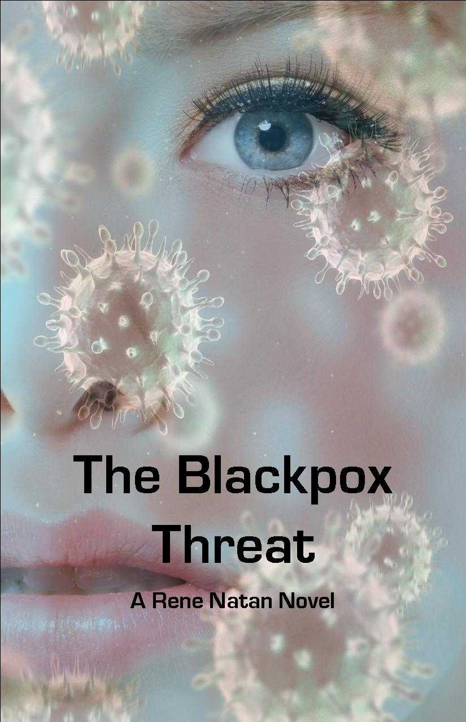
A deadly virus is on its way to Canada--from Ukraine via Italy. Would beautiful Tamara Smith, thirty-two, be able to help in the covert operation that the Canadian Security Intelligence Service has carefully orchestrated? Ship Me Safely, the European and Canadian-based company Tamara works for, is the suspected carrier of a newly engineered virus. The daughter of two political refugees, Tamara doesn’t know anything about viruses or spying as she is still mourning the loss of her parents, found dead in the family house, their throats slashed.
But when the only friend she has on earth--a Ukrainian Embassy diplomat--is murdered, she hesitates no more. She confronts Nekton, the mysterious man in possession of a virus that combines the deadly properties of smallpox with those of ebola. Betrayed by a fellow agent, she is kidnapped at gun point. Warned not to trust anybody, especially Justin Devry, the twenty-three-year-old son of a suspect who professes his love to her, Tamara risks her life for the cause and, against her beliefs, shoots to kill.

