ucardo reshuffles the cards  Web experts connect the printed business card with the digital world and make this innovation accessible to everyone  ucardo is the new generation of the business card. After scanning a QR-Code the scanning user will be directed to a smartphone optimized microsite. With one click the contact is storable in the local phone book and can be added to social networks. Printed on a business card, the Ucardo QR-Code bridges the gap between century-old tradition and modern web-based life. The testers of the “closed beta period” were enthusiastic about it, meaning that Ucardo can take the step forward into the “public beta period” with every owner of a business card invited along to try it for themselves – free of charge.  At a time when the majority of communication occurs electronically, the printed business card seems to be a relic from olden times. On the other hand it is an indispensable part of business life, rooted in time honored tradition. That is why ucardo offers a connection between the traditional business card and the digital world. With the help of an editor, which is extremely simple to operate, the user creates via Drag & Drop-System the online-equivalent (microsite) to his conventional business card. Inside his own layout as well as typical contact data he can add links to profiles on social networks or for example messenger. After finishing submission, a QR-Code is generated and can be printed on a conventional business card or for example digitally integrated into the email signature. While the user can update the content of his or her microsite at any time, the QR-Code remains unchanged.  After scanning the code the digital business card and all other additions appear immediately. All contact information is instantly storable in the local phone book. Furthermore the viewer is able to add the contact to social networks, if this addition was set – it works without typing one letter. What’s more is that almost every person has daily access to the necessary hardware – the smartphone. In October 2010 1 out 5 mobile phone users owned a smartphone. This figure was even higher at 1 in every 3 when surveying young people between 14 and 29 years of age. (Germany, source: Bitkom) This triumphant march of smartphones has opened up a plethora of new possibilities, which Ucardo uses innovatively. For more information please visit http://ucardo.com  About the company behind ucardo  The planetlan GmbH in Bochum (Germany) operates successful IT and event brands since 2000 and is one of the leading event service providers in the games industry. The company works for market leaders in both the IT and games industry as well as for fair organizers. For more information please visit the website www.planetlan-gmbh.de.  Current Screenshots  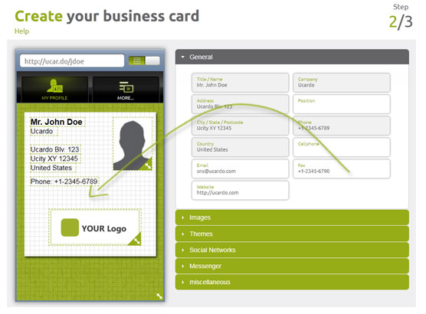    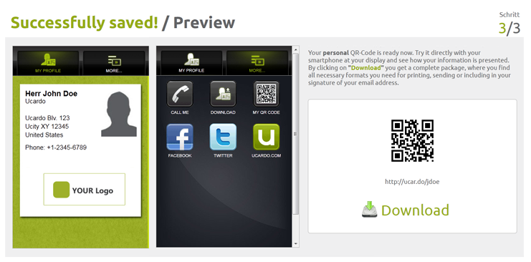    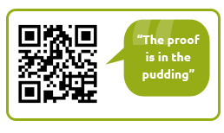    _____________________________________________________  Download of Screenshots and Media:  http://media.ucardo.com |   Press Release  Monday, 07.11.2011  – Page 1 of 2 –  free for publishing  specimen copy requested  Press contact:  planetlan GmbH  Marco Goetze  Lyrensraße 13  D – 44866 Bochum  Germany  Tel: +49 (0)2327 / 83 114 – 31  Fax: +49 (0)2327 / 83 114 – 99  E-Mail: mg@planetlan-gmbh.de  Website: www.planetlan-gmbh.de  Managing Directors:  Marco Götze  Josh Vögeding  Dipl. Ök. Michael Wegner  Amtsgericht Bochum, HRB 6947  UStID.: DE813102211  Press Release  Monday, 07.11.2011  – Page 2 of 2 –  free for publishing  specimen copy requested  Press contact:  planetlan GmbH  Marco Goetze  Lyrensraße 13  D – 44866 Bochum  Germany  Tel: +49 (0)2327 / 83 114 – 31  Fax: +49 (0)2327 / 83 114 – 99  E-Mail: mg@planetlan-gmbh.de  Website: www.planetlan-gmbh.de  Managing Directors:  Marco Götze  Josh Vögeding  Dipl. Ök. Michael Wegner  Amtsgericht Bochum, HRB 6947  UStID.: DE813102211

