Advanced Metal Roofing Named in Top Metal Roofing Companies Nationwide by
Metal Construction News

Advanced Metal Roofing is named as one of the top metal roofing companies in the nation for 2011 by Metal Construction News, a leading authority in the metal building industry. This is the fourth consecutive year that Advanced Metal Roofing has made the list of Top Metal Roofers. For more information, visit http://www.AdvancedMetalRoofing.com.

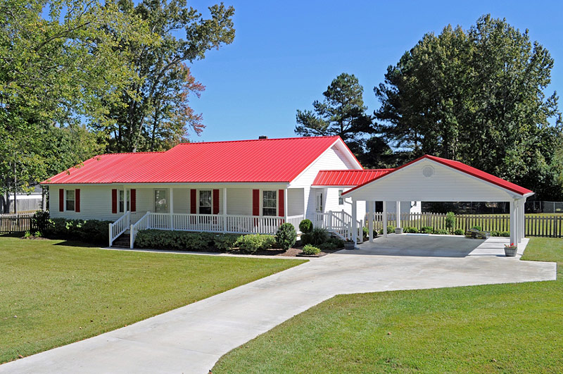
Wilmington, N.C. July 26, 2011 - James P. Kenton, owner and CEO of Advanced Metal Roofing, is pleased to announce that for the fourth consecutive year Advanced Metal Roofing has been named by Metal Construction News as one of the largest metal roofing firms in the nation. The July 2011 issue of Metal Construction News lists Advanced Metal Roofing as the second largest metal roofer by square footage installed, the same position it held in 2010.
Advanced Metal Roofing is a leading residential metal roofing company currently serving homeowners in North Carolina, South Carolina, and Massachusetts with expert metal roof product and installation. They are the exclusive dealers for the patented MetalMan Roofing System® featuring Galvalume Steel and Kynar 500 Paint Finish. These features ensure durability, long life expectancy, vibrant and long lasting metal roof colors, as well as significant energy savings. In addition, every roof comes with a limited Lifetime Warranty. Advanced Metal Roofing takes great pride in their product, service, and expertise in the field of metal roofing.
Metal Construction News is an authority in the metal building industry, publishing news related to businesses, products, and strategies in the metal construction field. According to their website, they are "devoted to educating building systems contractors, general contractors, suppliers, manufacturers and more..." Each year, Metal Construction News publishes results of the Top Metal Roofers based on square footage and tonnage installed. Advanced Metal Roofing has made that list for the past four years.
James Kenton attributes his company’s continuing success to the demonstrated quality of its products, namely the MetalMan Roofing System®, and Advanced Metal Roofing’s emphasis on superior workmanship and customer service. "The MetalMan Roofing System offers advantages to homeowners," comments Mr. Kenton, "including the cool roof technology that helps lower home energy costs during peak seasons and the Kynar 500 finish that helps preserve and maintain the vivid roof colors over a long period of time."
Metal Construction News conducted a survey of the 2011 Top Metal Roofers to determine how they've been able to thrive in a struggling economy (see: http://www.metalconstructionnews.com/articles/magazine-features/the-2011-top-metal-roofers.aspx). Many of the roofing companies, including Advanced Metal Roofing, have experienced success because they focus on retrofit work, or re-roofing on existing homes and buildings, while the new construction market has been slow to recover. Retrofit work makes sense to homeowners because the return on investment (ROI) with a metal roof is strong given the long life expectancy, low maintenance, durability, and energy savings. It is a smart, sound home improvement investment that eliminates the need for further re-roofing for 50 years or more.
For more information about Advanced Metal Roofing, including an interactive Metal Roof Color Simulator, portfolio, and customer reviews, visit http://www.AdvancedMetalRoofing.com. To learn more about the MetalMan Roofing System, visit http://www.MetalManRoofing.com.

Contact:

James Kenton
Advanced Metal Roofing
309 Raleigh Street
Suite C
Wilmington, N.C. 28412
877-858-7663
info@advancedmetalroofing.com
http://www.AdvancedMetalRoofing.com

