Advanced Metal Roofing Ranks in the 2011 Top 100 Roofing Contractors

Advanced Metal Roofing announces their place in the 2011 Top 100 Roofing Contractors compiled by Roofing Contractor Magazine. Among roofers of all sizes and in all markets, including commercial and general roofing contractors, Advanced Metal Roofing is one of the only residential metal roofing specialists who made the Top 100 list.

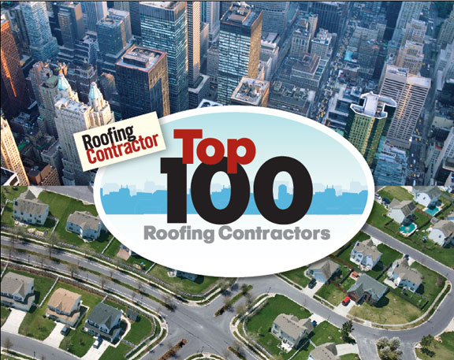
Wilmington, N.C. August 2011 -- Advanced Metal Roofing is proud to announce that they have made the 2011 Top 100 Contractors list compiled by Roofing Contractor Magazine. The list is comprised of roofers of all types throughout the U.S., including commercial roofers and general roofing contractors. Advanced Metal Roofing placed number 60 on the list and is one of the few specialty residential metal roofing contractors to make the Top 100.
The 2011 Top 100 Roofing Contractors list is part of a yearly survey of roofing companies nationwide where rankings are based on annual revenue from the previous year. Advanced Metal Roofing has made the list for three consecutive years and has moved up from number 65 in 2010 to number 60 in 2011.
Roofing Contractor Magazine, publisher of the 2011 Top 100 Roofing Contractors, says "The contractors on Roofing Contractor's Top 100 list know what it takes to remain successful in tough times and in good times." Widespread economic challenges in 2010 had a major impact on roofing and construction companies. Those who were able to survive and thrive did so by making adjustments to their operations, including expanding their coverage area or reducing their focus on new construction and concentrating more on re-roofing projects. Maintaining priorities on quality, workmanship, reputation, and relationships always remain critical factors in the success and growth of a roofing company.
Advanced Metal Roofing believes that their success lies in the superiority of their metal roof product and expertise as well as their commitment to sound and attentive business practices. Advanced Metal Roofing is the exclusive dealer of the patented MetalMan Roofing System panel featuring Kynar 500 Paint Finish, Galvalume Steel, and Cool Roofing Technology. Benefits of the MetalMan Roofing System for homeowners include significant energy savings, long life expectancy with minimal maintenance, and resistance to high winds and storm damage. Homeowners can expect to reap a rapid return on their investment with their MetalMan Roofing System in terms of energy savings, energy efficiency tax credits, and savings on roof repair and maintenance.
Founded in 1994, Advanced Metal Roofing is a family owned and operated business which currently serves residents throughout North Carolina and South Carolina. They are actively expanding their service area to meet demand as more homeowners are realizing the money saving and home protection value of a metal roof. They are proud of their success in business despite the tough economic climate of the last few years, especially in the home construction industry. Because their focus is predominantly on full re-roofing projects, Advanced Metal Roofing has been able to benefit their customers with a high performance metal roofing product while achieving growth and success as a business.
Learn more about Advanced Metal Roofing and see a portfolio of their work by visiting http://www.AdvancedMetalRoofing.com. Get details about the MetalMan Roofing System at http://www.MetalManRoofing.com.

Contact:

James Kenton
Advanced Metal Roofing
309 Raleigh Street
Suite C
Wilmington, N.C. 28412
877-858-7663
info@advancedmetalroofing.com
http://www.AdvancedMetalRoofing.com

