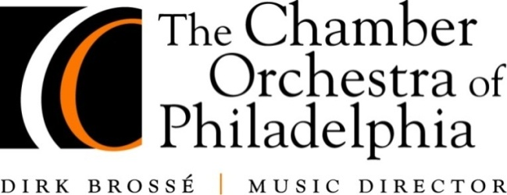
PRESS RELEASE
For Immediate Release
September 19, 2012

Contact
Dara N. Boyd
Director of Marketing and Interactive Media
215.545.5451 x31

dboyd@chamberorchestra.org

The Chamber Orchestra of Philadelphia Presents
HAYDN | BEETHOVEN
featuring Violinist Lorenzo Gatto

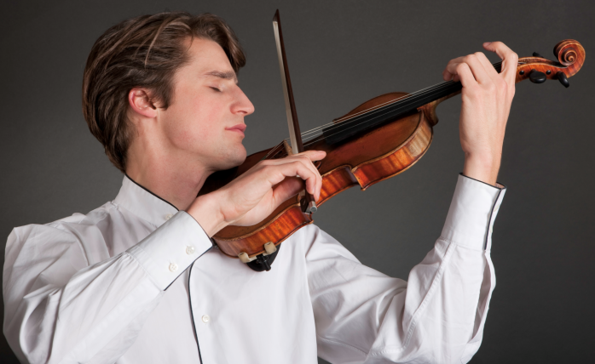
The Chamber Orchestra of Philadelphia, a founding resident company of The Kimmel Center for the Performing Arts, announces its opening concerts of the 2012-2013 season. The orchestra will perform Haydn | Beethoven on September 30 and October 1. The program features finalist of the Queen Elisabeth International Music Competition, violinist Lorenzo Gatto.

The September 30 2:30 p.m. and October 1 7:30 p.m. concerts will be performed in the Kimmel Center’s intimate Perelman Theater as part of the 2012-2013 subscription series.

Tickets for Chamber Orchestra performances are $24 to $81. The Sunday matinée performance will be followed by “Classical Conversations,” a brief question-and-answer session with Maestro Brossé and Mr. Gatto.

On the program is Music Director Dirk Brossé’s Sire, Joseph Haydn’s Symphony No. 96 in D major, HOB. 1:96, “The Miracle”, and Ludwig van Beethoven’s Violin Concerto in D major, Op. 61.

Commissioned by the Belgian government to celebrate the 10th anniversary of King Albert II’s accession to the throne, Dirk Brossé’s Sire describes ten pivotal moments in the monarch’s life. Sire was composed in 2003 for string orchestra, and based on the notes B and D, which are used 1,934 times throughout the piece – 1934 being the year King Albert was born. Brossé also incorporates the number 59, King Albert’s age when he was crowned in 1993, as the amount of times the head of the theme is heard. These are the Chamber Orchestra’s first performances of Sire as part of its subscription series.

The numbered order of Haydn’s twelve “London” symphonies, No. 93 through No. 104, does not correspond with the order of their composition, since Symphony No. 96 was the first one he wrote for London. Symphony No. 96 premiered in 1791 and emphasizes the oboe throughout the piece. It supposedly received its nickname “The Miracle” from a life-saving incident during the premiere of Symphony No. 96, where several members of the audience changed seats to have a better view of the conductor, Haydn, unknowingly eluding a chandelier that was to fall on their original seats moments later. However, the story remains questionable because this incident is in fact said to have happened at the performance of a different symphony, No. 102, four years later. Still, No. 96 finds itself miraculous in its own right, giving recognition to Haydn’s glory days in London. These are also the first performances of Haydn’s Symphony No. 96.

Beethoven wrote his Violin Concerto in 1806 for Austrian violinist Franz Clement at a time when his deafness was encroaching. His increasing difficulty in communicating with others is reflected in the piece, drawing more poignant differentiation between the one and the many – or the violin and the orchestra, as in his own life. Dramatic in nature, his Violin Concerto has an even larger scale and breadth than Mozart’s concertos, and Beethoven’s contribution to the evolution of the concerto form is demonstrated when the slow movement transitions into the finale – without a pause, and with great dramatic effect. The Chamber Orchestra of Philadelphia’s only previous performances of Beethoven’s Violin Concerto were conducted by Ignat Solzhenitsyn at the Perelman Theater with Jennifer Frautschi as the soloist, in March 2004.

Violinist Lorenzo Gatto is hailed by the press as a “creative artist” and “passionate virtuoso.” He won second prize and Public’s prize at the prestigious Queen Elisabeth International Music Competition in 2009, as well as the first prize and Public’s prize at the International RNCM Competition in Manchester and first prize at the International Andrea Postacchini Competition in Italy. He has played at famous festivals and halls in Europe, including the Palais de Beaux-Arts (Bozar) and Flagey in Brussels, Philharmonie in Luxemburg and Salle Cortot in Paris. Gatto has also appeared with renowned orchestras such as the BBC Philharmonic Orchestra, the Belgian National Orchestra and the Royal Flemish Orchestra. Aside from performing, he co-founded the Cl4ssiK association, with the aim of encouraging young people to be more aware of classical music.

The first Friday Conversations at the Philadelphia Art Alliance will take place on September 28, 2012 at 6:45 PM where Music Director Dirk Brossé and Executive Director Peter H. Gistelinck will discuss the new season and more. Following, guests will have the opportunity to chat and mingle with them over complimentary wine and hors d’oeuvres. General Admission is $5. Free entry is offered to Chamber Orchestra subscribers and Philadelphia Art Alliance members. Friday Conversations will also be broadcast live on brandywineradio.com. The Philadelphia Art Alliance is located at 251 South 18th Street in Philadelphia. For information about Friday Conversations, call 215.545.4302 or visit philartalliance.org.

The Chamber Orchestra of Philadelphia is a founding resident company of The Kimmel Center for the Performing Arts and performs from September through May in its home, the intimate Perelman Theater. For information, please contact the Chamber Orchestra at 215.545.1739 or visit www.chamberorchestra.org.

***

The Chamber Orchestra of Philadelphia

Haydn | Beethoven

Sunday, September 30, 2012 at 2:30 PM

Monday, October 1, 2012 at 7:30 PM

Kimmel Center for the Performing Arts’ Perelman Theater

Dirk Brossé, conductor

Lorenzo Gatto, violin

Program:

Brossé | Sire

Haydn | Symphony No. 96 in D major, Hob. I:96, “The Miracle”

Beethoven | Violin Concerto in D major, Op. 61

Tickets:

Kimmel Center Performances $24 - $81

215.893.1709 or chamberorchestra.org

###

