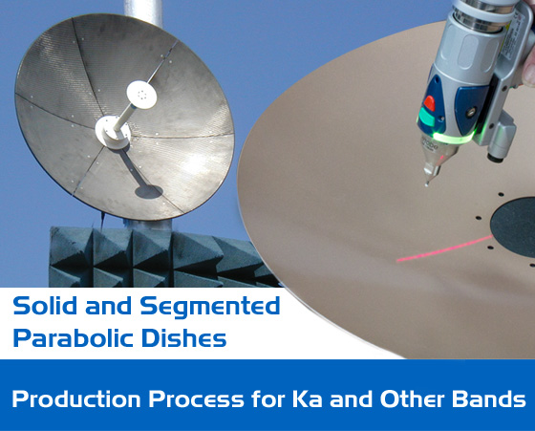
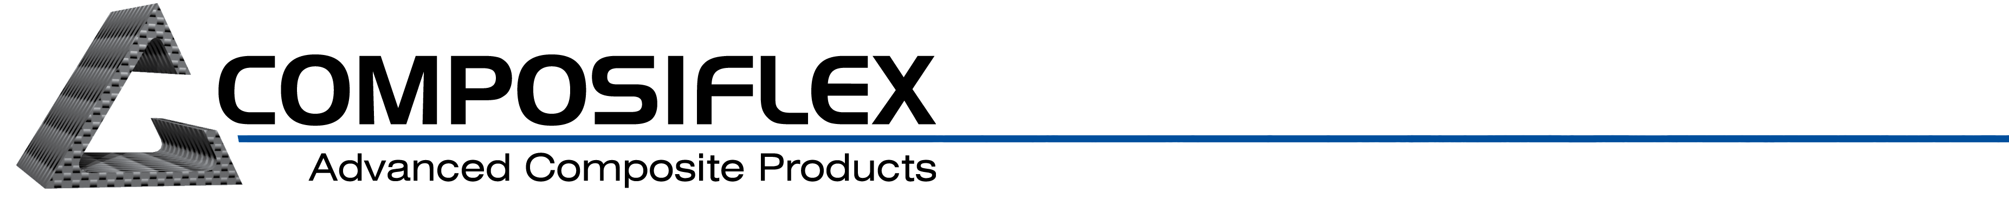

Contact:
Marty Matthews
(814) 866-8616
martym@composiflex.com
www.composiflex.com

FOR IMMEDIATE RELEASE

COMPOSIFLEX SHOWS Ka BAND DISH CARBON FIBER ANTENNAS AT SATELLITE 2013 MARCH 19TH (Booth #9103) IN WASHINGTON D.C. AT WALTER E. WASHINGTON CENTER.

Composiflex showcases Ka Band carbon fiber dish antennas at Satellite 2013.

ERIE, PA (March 11, 2013) - - Composiflex, a global supplier of highly-engineered composite products, has successfully manufactured parabolic dish antennas that operate at Ka band. The company has launched production processes to produce Ka and other band antenna products and will be showcasing these products at Satellite 2013 in Washington D.C. March 19th at booth #9103.
Improvements in mold tolerance plus an ability to control process variation have been instrumental in developing and tuning processes for these demanding high-frequency applications. Both solid and segmented dish styles will be manufactured using these production techniques.
Composiflex offers a variety of options to provide the reflectivity needed to achieve suitable gain. These options include reflective paints and coatings, conductive composite materials, and deposition treatments.
“Our customer are looking for advanced composite solutions at affordable cost points,” said Marty Matthews, Composiflex Marketing Executive. Matthews also noted that, “We are targeting solutions for the rapidly growing market of Ka band satellite communications for both military and commercial applications.”
Composiflex is looking forward to discussing these developments at this month’s SATELLITE 2013 in Washington D.C. Check out our SATCOM Website or Give us a call at 1-800-673-2544.
To download a word document with this information please click here

About Composiflex

For over a quarter century, Composiflex has been an innovator in the design and manufacture of advanced high-performance composites. Specializing in custom designs, Composiflex serves military, aerospace, medical, and other markets. The company is characterized by its “art-to-part” projects made possible by its knowledgeable engineering staff, broad materials expertise, cost-effective rapid prototyping methods, and range of modern manufacturing technologies. Certified to ISO 9001:2008 and AS9100:2009 standards, Composiflex conducts operations in Erie, PA, USA. More details are available at www.composiflex.com.

###

