FOR IMMEDIATE RELEASE
Tuesday, January 4, 2022

Contact:
Holly Jo Anderson
952-738-8177, ext. 700
holly@veritasmarketing.com

Diversified Plastics, Inc. manufactures highly complex, close-tolerance plastic parts for Helius Medical Technologies, Inc.’s PoNS™ device
An innovative nonsurgical device, PoNS delivers electrical stimulation to the surface of the tongue to provide treatment of balance and gait deficits

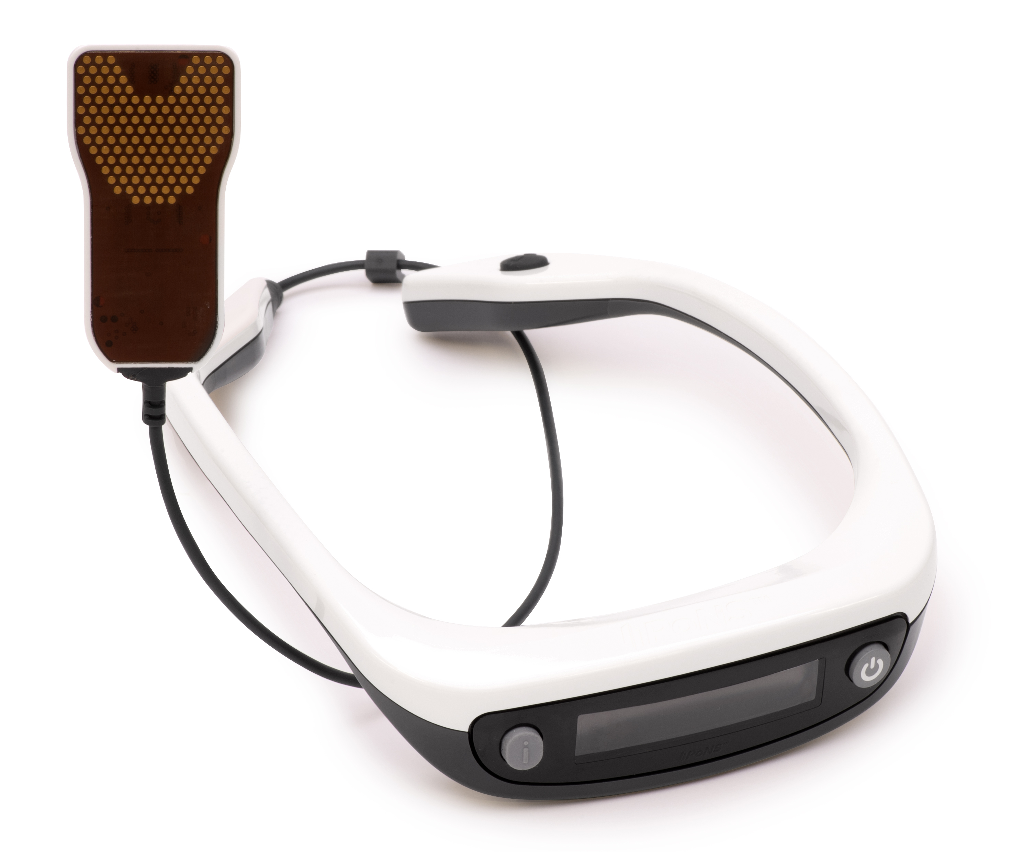
MINNEAPOLIS — Helius Medical Technologies, Inc., in Newtown, Pa., has developed and is marketing the Portable Neuromodulation Simulator (PoNS™). A breakthrough medical device, PoNS is indicated for use in the United States as a short-term treatment of gait deficit due to mild to moderate symptoms from multiple sclerosis (MS) and is to be used as an adjunct to a supervised therapeutic exercise program in patients 22 years of age and over by prescription only. PoNS is authorized for sale in Canada for two indications:
- As a short-term treatment (14 weeks) of chronic balance deficit due to mild to moderate traumatic brain injury (mmTBI) and is to be used in conjunction with physical therapy.
- As a short-term treatment (14 weeks) of gait deficit due to mild and moderate symptoms from MS and is to be used in conjunction with physical therapy.

Additionally, PoNS is authorized in Australia as a nonimplantable neurostimulator intended for short-term use by health care professionals as an adjunct to a therapeutic exercise program to improve balance and gait. It is not intended to be used alone without an exercise program.

The PoNS medical device has a complicated design with difficult-to-manufacture, close-tolerance plastic parts. It is produced through a partnership between Keytronic, headquartered in Spokane, Wash., and Diversified Plastics, Inc. (DPI) in Minneapolis, Minn.

A contract manufacturer, Keytronic builds the electronic components and completes the assembly of the PoNS product in its Oakdale, Minn., facility. In the early stages of production, Keytronic worked with a supplier in China to develop high-quality tools and to produce samples of the plastic components. To streamline logistics, Keytronic reviewed plastic-injection molding companies in the United States. The goal was to establish a partnership with a company near its Minnesota facility. After reviewing several potential molders, Keytronic selected DPI to produce the plastic components for the PoNS medical device.

“DPI and Keytronic work well together,” says Gerry Huber, director, manufacturing management, supply chain and logistics at Helius. “Manufacturability of the mouthpiece was particularly challenging. The team at DPI has worked diligently with the design house and Keytronic to adjust dimensions and improve manufacturability of the finished parts. Some of the components are so intricate that we can’t take the work anywhere else. I am confident of DPI’s ability to work with us for continuous improvement and to meet growing production demand.”

The PoNS device consists of a neckpiece with a controller, information display and function buttons. The mouthpiece has a flat surface, with gold-plated electrodes, that attaches to the controller by a cord. Four PoNS plastic parts are manufactured at DPI. In addition to the tolerance complexities of the mouthpiece components, one of the PoNS parts is overmolded twice, an advanced manufacturing process.

“Having a great collaborative team has been critical to solving the manufacturing challenges for PoNS,” says Bart Bills, program manager/planner at Keytronic. “In addition to improving the manufacturability of the parts, DPI has made modifications to reduce scrap. PoNS is such a life-changing product, that everyone on the team wants to see it succeed and benefit people throughout the world.”

For more information about DPI’s capabilities or to request a quote, visit divplast.com or call +1 763.424.2525.

PoNS Medical Device
The Portable Neuromodulation Stimulator (PoNS) is an innovative nonsurgical device, inclusive of a controller and mouthpiece, which delivers electrical stimulation to the surface of the tongue to provide treatment of gait deficit. The PoNS device is indicated for use in the United States as a short-term treatment of gait deficit due to mild to moderate symptoms from multiple sclerosis (MS) and is to be used as an adjunct to a supervised therapeutic exercise program in patients 22 years of age and over by prescription only. It is authorized for sale in Canada for two indications:
- As a short-term treatment (14 weeks) of chronic balance deficit due to mild to moderate traumatic brain injury (mmTBI) and is to be used in conjunction with physical therapy.
- As a short-term treatment (14 weeks) of gait deficit due to mild and moderate symptoms from MS and is to be used in conjunction with physical therapy.
Additionally, PoNS is authorized in Australia as a nonimplantable neurostimulator intended for short-term use by health care professionals as an adjunct to a therapeutic exercise program to improve balance and gait. It is not intended to be used alone without an exercise program.

Multiple Sclerosis (MS)
According to recent findings from a National Multiple Sclerosis Society study, it is estimated that nearly 2.3 million people worldwide are living with MS. It is a potentially disabling disease of the brain and central nervous system. Symptoms differ from person to person and typically have a relapsing-remitting course. MS often affects movement, with weakness in one or more limbs. Worsening of symptoms usually include problems with mobility and gait.

###

Helius Medical Technologies, Inc.
Helius Medical Technologies is a leading neurotech company in the medical device field focused on neurologic deficits using nonimplantable platform technologies that amplify the brain’s ability to compensate and promote neuroplasticity, aiming to improve the lives of people dealing with neurologic diseases. The company’s first commercial product is the Portable Neuromodulation Stimulator (PoNS). For more information, visit www.heliusmedical.com.

Keytronic Corporation
Keytronic is a leading contract manufacturer offering value-added design and manufacturing services from its facilities in the United States, Mexico, China and Vietnam. Keytronic provides its customers full engineering services, materials management, worldwide manufacturing facilities, assembly services, in-house testing and global distribution. Its customers include some of the world’s leading original-equipment manufacturers. For more information about Keytronic, visit keytronic.com.

Diversified Plastics, Inc.
Employee-owned Diversified Plastics, Inc. (DPI) is a custom plastic-injection molder and digital manufacturer of high-precision, close-tolerance parts and components for medical device, filtration, aerospace and a variety of other industrial markets. Founded in 1977, the company is a full-service contract manufacturer providing design for manufacturing assistance, additive manufacturing, mold construction and intricate molding, as well as cleanroom assembly. DPI is a Carbon® Production Network partner. The Carbon Digital Light Synthesis™ (DLS™) process is the backbone of DPI’s Acceleration Station™, which deliver a faster path to market for its customers. In 2018, DPI purchased Pacific Plastics Injection Molding in Vista, Calif. DPI is ISO 9001:2015 and 13485:2003 certified, FDA registered, ITAR certified and UL registered. divplast.com

