FOR IMMEDIATE RELEASE
February 8, 2022

CONTACT: Holly Jo Anderson
+1 952.738.8177, ext. 700
holly@veritasmarketing.com
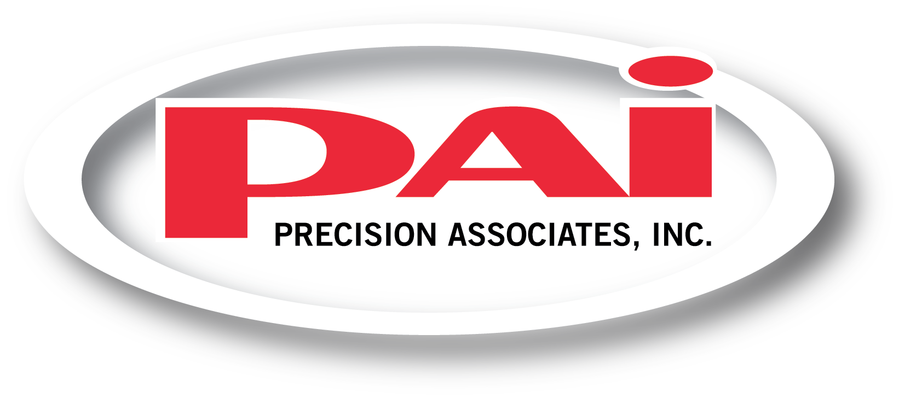
Precision Associates, Inc. expands its ISO Class 7 cleanroom manufacturing space to meet growing customer demand

MINNEAPOLIS—Precision Associates, Inc. (PAI), a provider of high-performance, consistent sealing solutions and precision-molded rubber products, recently completed a significant cleanroom expansion in its 130,000-square foot Minneapolis facility. The now 13,000-square foot ISO Class 7 cleanroom will allow the company to meet growing demand for rubber part manufacturing from current and new medical device and other customers.

84 HEPA filters were added to the expanded space, which includes silicone and rubber molding, mold prep and quality assurance rooms as well as a gowning area and observation tower.

In addition to the expansion, PAI is increasing its capabilities to include liquid silicone rubber (LSR) injection molding. A popular material selection for medical device components because of its biocompatibility with body tissue, LSR is used to manufacture seals and custom parts for diabetes glucose monitoring, neuro stimulation, respiratory care, infusion therapy, catheters, drug delivery, pacemaker leads, implantable and other devices.

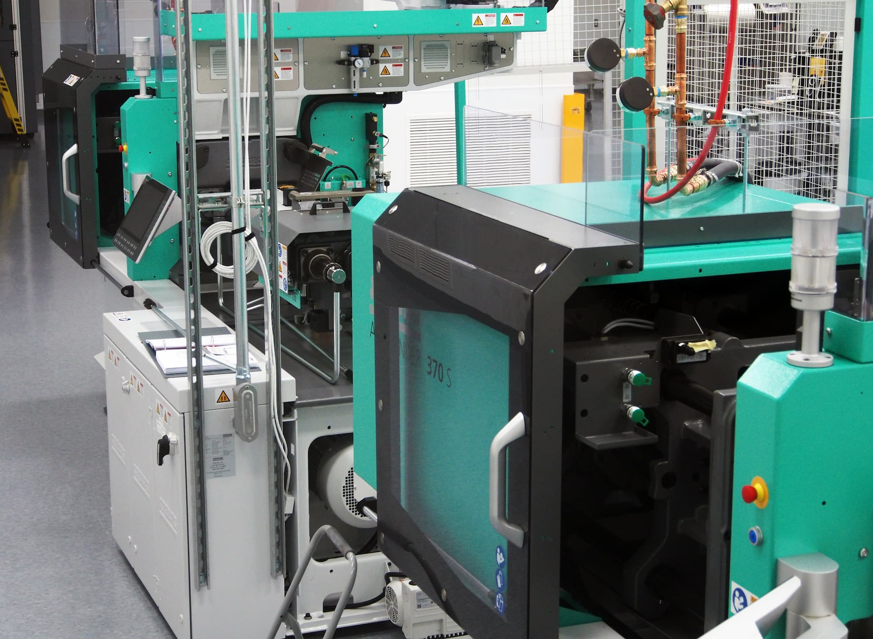
“This expansion has more than doubled our cleanroom capacity,” says Bridget Hanson, vice president of sales and marketing at PAI. “Increasing our cleanroom manufacturing space and adding LSR injection molding is a testament to our commitment for continuous improvement and meeting growing demand from our customers.”

For more information or to request a quote, call +1612.333.7464 or 1.800.384.6590 or visit precisionassoc.com/contact-us/. You can also download PAI’s informative process validation white paper at www.precisionassoc.com/validation.

###
Precision Associates, Inc.
Precision Associates, Inc. (PAI) is a leader in high-performance, consistent sealing solutions and precision-molded rubber products that exceed requirements in diverse industries. Experts in advanced material formulation, PAI has more than 1,000 formulations engineered for your requirements. The company manufactures micro- and miniature rubber O-rings that are 0.004” (0.1 mm) to larger, complex components that are 36” (914 mm) in size. In addition to custom seals and rubber products, PAI offers over 3,000 standard seals. Many catalog products are in stock and ready for immediate shipment. PAI provides engineering and manufacturing services for custom seals and parts as well as immediate shipment for in-stock, standard O-rings, lip seals and other seals.

