FOR IMMEDIATE RELEASE  Wednesday, February 16, 2022 | CONTACT: Holly Jo Anderson  +1 952-738-8177, ext. 700  holly@veritasmarketing.com
Multi-Wing announces new manufacturing facility in Texas
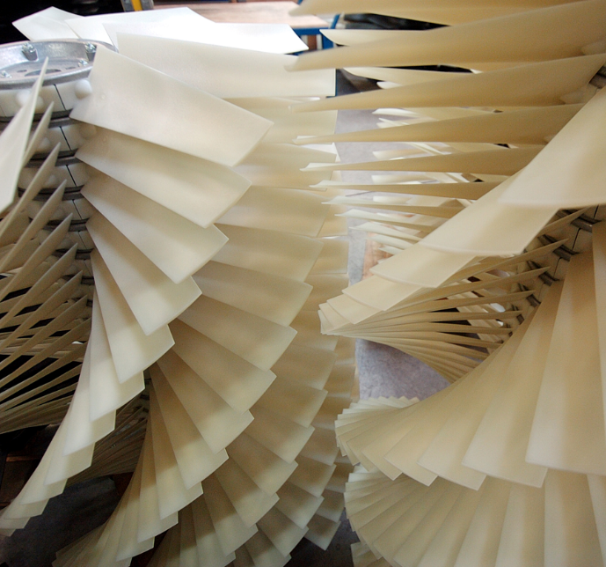
Middlefield, Ohio—Multi-Wing America, the North American subsidiary of Multi-Wing Group, has opened a new manufacturing plant in New Caney, Texas. Near Houston, the facility has begun production of select high-volume Multi-Wing modular axial fans for engine cooling and HVACR applications. Additionally, SMARTPACK™ and CUSTOMFAN™ fan packs, from E Flow Technologies, will be manufactured in the new facility. E Flow
Technologies is an entity of Multi-Wing Group.
“Multi-Wing Group is committed to providing the best possible service to our North American customers,” says Palle Linde, president of Multi-Wing America. “By opening this plant, we are able to accommodate current and future growth and improve delivery times. We also now have a facility that is closer to several key customers.”
The Houston area was selected to complement the company’s current manufacturing plant in Ohio. In addition to offering large customers in the southern United States and Mexico improved delivery times and cost savings, the location was selected because of the area’s strong labor force and friendly regulatory environment.
The same quality system that is in place in Ohio has been established in Texas. In addition to hiring new employees in the area, a few key Ohio employees have relocated to further establish and maintain the maximum continuity and quality that customers expect from Multi-Wing and E Flow.
To discuss your specific application with one of our engineering support specialists, visit www.multi-wing.net, call 1-800-311-8465 or email info@multi-wing.net. To learn about E Flow Technologies products, visit www.eflowtec.com.
###
Multi-Wing Group
Multi-Wing Group was established in the United States, Canada and Mexico in 1972 as Multi-Wing America. Headquartered in Middlefield, Ohio, Multi-Wing America is North America’s leading supplier of high-performance, modular axial fans in the broadest range of materials and blade profiles. Multi-Wing America is ISO 9001:2015 and 14001:2004 certified.

E Flow Technologies
A global company, E Flow Technologies is an entity of the Multi-Wing Group. E Flow Technologies delivers exceptional service and high-efficiency products to exceed stringent and ever-changing requirements for the commercial and industrial HVACR, heat exchangers and engine cooling industries. E Flow Technologies produces the most energy-efficient fan packs, which include custom-configured, high-performance Multi-Wing impellers and a broad selection of AC and EC motors. E Flow’s SMARTPACK and CUSTOMFAN fan packs deliver a quick return on investment for HVAC, refrigeration, ventilation and engine cooling industries. The team at E Flow Technologies has more than 60 years of industry experience. Their technical expertise, business awareness and application insights bring advanced innovation to every fan product and customer solution.

