FOR IMMEDIATE RELEASE
Tuesday, June 7, 2022
CONTACT:
Holly Jo Anderson
952-738-8177, ext. 700
holly@veritasmarketing.com

pinta acoustic introduces three new CONTOUR® Ceiling Tile patterns
Three new patterns provide a modern look and visual movement

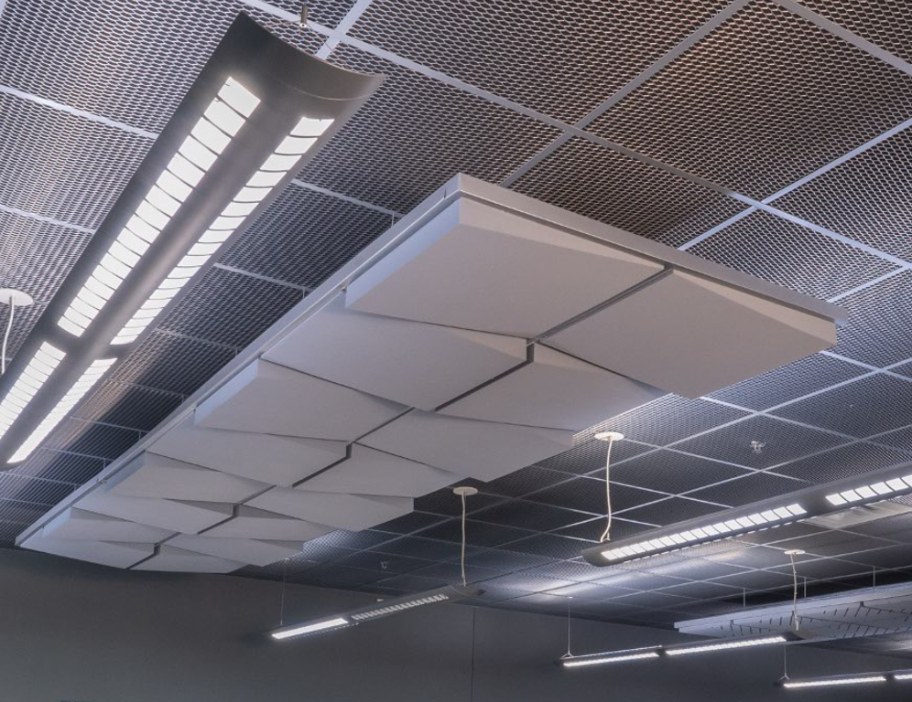
MINNEAPOLIS ⎯ pinta acoustic’s CONTOUR® Ceiling Tiles are now available in three new patterns, including Labyrinth, Taper and WHISPERWAVE™. They create modern effects while absorbing unwanted noise. Ideal for small- and large-scale indoor spaces, CONTOUR Ceiling Tiles are used in modern offices, lobbies, retail spaces, restaurants, entertainment facilities, worship centers and more.
“The three new CONTOUR patterns provide dynamic visual style with exceptional sound absorption,” says Jean Sebastien Marineau, business unit manager at pinta acoustic, inc. “In addition to our standard CONTOUR patterns, we offer custom options, including company logos.”

New Patterns:
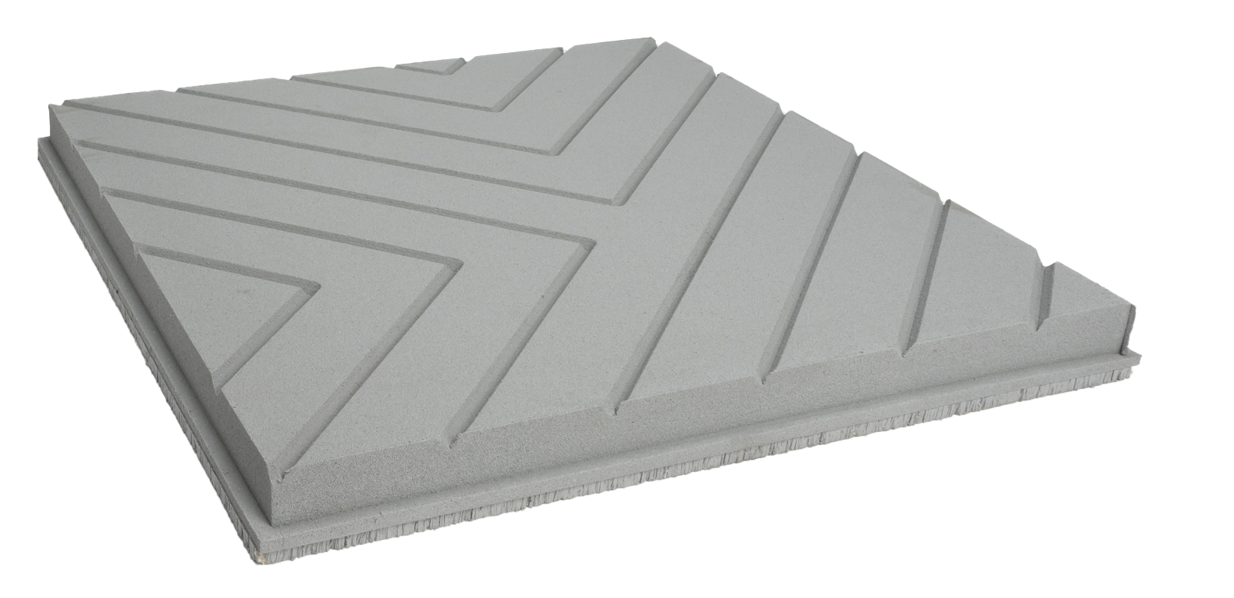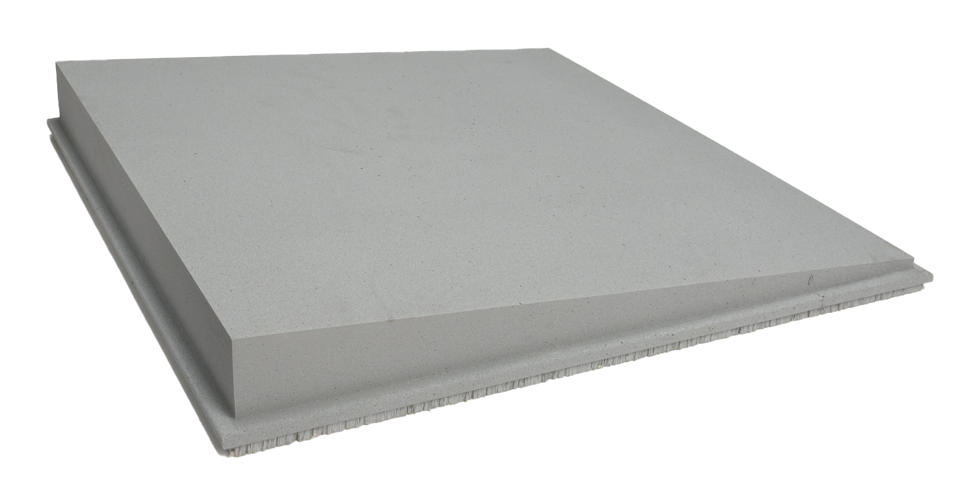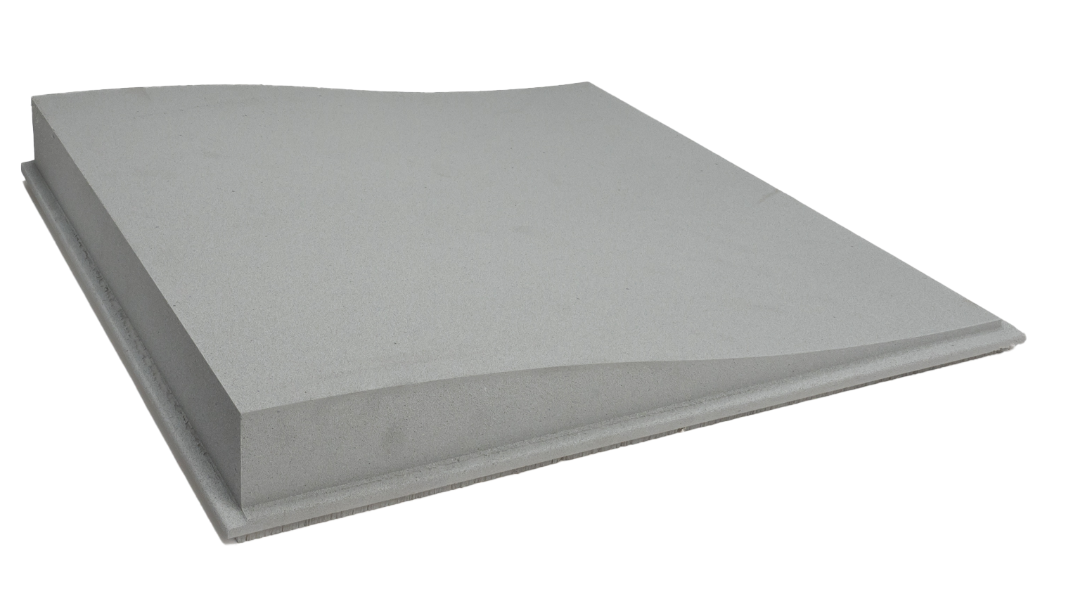
Labyrinth Taper WHISPERWAVE™

Made with open-cell, mold-resistant WILLTEC™ foam, CONTOUR Ceiling Tiles are offered in two styles for easy, efficient ceiling grid or glue-up installation. CONTOUR tiles offer a noise reduction coefficient (NRC) up to 1.20. CONTOUR tiles pass Class A per ASTM E 84, CAN ULCS-102 and University of Pittsburgh Toxicity of Smoke Emission test.
Standard direct-apply, glue-up tiles are 24 by 24 inches (610 by 610 mm) in thicknesses of 1 or 1-3/4 inches (25 or 44 mm). Suspended ceiling grid tiles fit in standard 15/16-inch (24 mm) grid systems and have a backerboard that blocks sound from traveling into adjacent rooms with a ceiling attenuation class (CAC) of 34. Ceiling grid tiles are 23 inches (584 mm) square with thicknesses of 1-3/8 or 2-1/8 inches. CONTOUR Ceiling Tiles are available in natural white or light grey, and water-based acoustic coating is available in standard, premium and custom colors for easy cleaning and durability.
For more information or to find a representative, visit www.pinta-acoustic.com or call 1.800.662.0032 or +1.612.355.4200. To download “The Science of Better Acoustics” white paper, go to https://bit.ly/acousticscience.
pinta acoustic, inc. manufactures a broad range of attractive direct-apply, glue-up ceiling and wall panels, suspended lay-in grid panels, suspended baffles and clouds for residential, commercial and industrial applications. pinta acoustic’s product line includes WHISPERWAVE™, PHONSTOP™, CONTOUR®, HARMONI, WHITELINE®, SQUARELINE®, WILLTEC™ Flat Sheets, SONEX® Classic, SONEX Valueline, SONEX One, SONEX Mini, SONEX AFS, SONEX Linear Absorbers, SONEX Lumen Linear Absorbers, SONEX PLANO Absorbers, SONEX Rondo, SONEX Clean, PROSPEC® Barrier, Foam and Composite Materials, and acouSTIC™ adhesives.
###

Editor’s note: pinta acoustic, inc. prefers lowercase spelling of its entire name.

