SIYA RELEASES MIXED EMOTIONS, HER FIRST EP VIA HILLMAN GRAD RECORDS/DEF JAM RECORDINGS

STAR OF NEW BET+ SERIES, ANGEL, FIRST SEASON EPISODES PREMIERED IN JANUARY

STREAM HERE

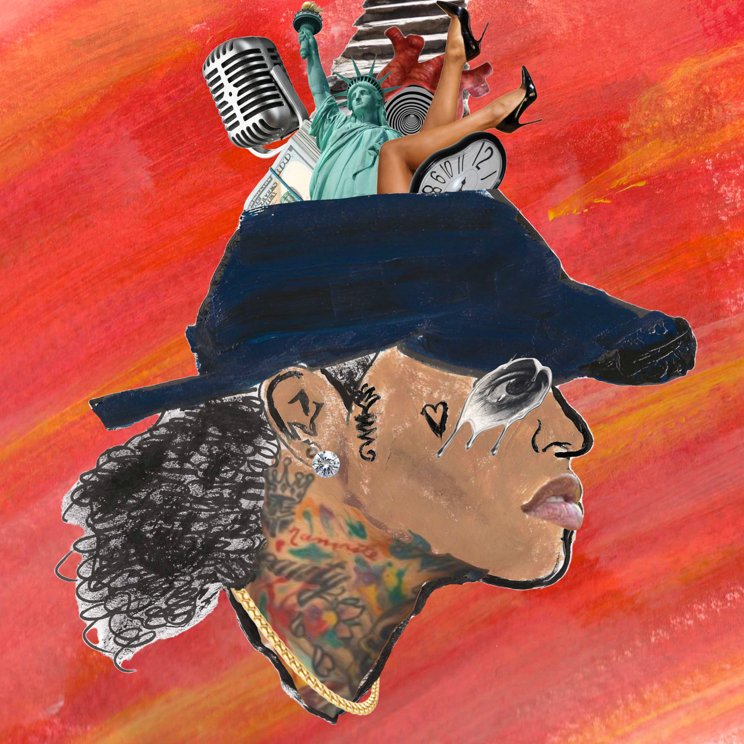

Jan. 27, 2023 – Siya, the Bed-Stuy Brooklyn-bred rapper and actor whose brand new BET+ syndicated television series Angel premiered this month, makes her long-awaited return to the front line with MIXED EMOTIONS EP, stream here via Hillman Grad Records/Def Jam Recordings.

MIXED EMOTIONS is the first new music from Siya since Mad Energy (December 2019), including “No Race” and “Circle Watchin.” It was her first album on her own after parting ways with artist, songwriter, producer, and actor Durrell ‘Tank’ Babbs and his R&B Money LLC label.

After her debut album on the label in 2016, SIYAvsSIYA, she went on to release a series of mixtapes culminating with two EPs in 2017: Commitment (with “Don't You (Say Yes)” featuring Tank); and 383 - For Roosevelt, in homage to the Eleanor Roosevelt housing projects in Bed-Stuy where her grandmother raised her, with “Houston Girls” featuring Kirko Bangz, and “Hot Girl.”

In 2020, before Angel, Siya was already into her fourth film role, writer-director-producer Will Wernick’s horror story, No Escape (aka Follow Me). Siya’s movie career began in 2016, on the Netflix crime drama Deuces from writer-director Jamal Hill. Siya was then seen in two 2018 releases: The First Purge, the fourth chapter in the worldwide megahit franchise; followed by writer-director Jordan Cann’s undercover police drama Street Dreams - Los Angeles.

Angel got off to a strong premiere when all three episodes of the first season aired on January 5th. The series introduces Efrangeliz Medina as Angel Alvarez, an abused young Latina foster child who flees home to survive on the mean streets of Los Angeles.

The cast includes Siya as Angel’s girlfriend Diamond (whose evil intentions are quickly revealed), along with dj MC Lyte, and stylist E.J. King. The series is based on the best-selling trilogy of “Dutch” novels written by Teri Woods, which chronicle 14-year-old Dutch’s entry into a life of street crime, similar to the Angel character. Angel is produced by Manny Halley, his first tv series after previously helming 11 BET+ movies.

ABOUT SIYA
Resilient. Advocate. Creative. Just a few words to describe rapper Siya, who has easily been noted as a highly reputable emcee of our time. Born Michele Sherman in Barstow, California, she relocated to Brooklyn’s Bed-Stuy neighborhood as a child, where she was raised by her grandmother. In her early 20s, Siya moved to Atlanta to begin her journey as a rap artist. She quickly gained the attention of prominent music reps, particularly R&B legend and actor Tank (aka Durrell Babbs). Siya signed to his label, R&B Money, and relocated to Los Angeles to begin working on new music.

In 2014, the young rapper became the star of Oxygen's highly-rated reality show, Sisterhood of Hip-Hop, executive produced by rapper T.I. and Cris Abrego. After leaving the show and parting ways with Tank's label, Siya had to focus on creating a new path toward continuous musical and film success. Battling her clinical anxiety, Siya found her therapy in the creation of her latest project, Mad Energy. While she is in between making films and rocking out stages, she has become an advocate for individuals who suffer from severe anxiety.

Siya has faced many obstacles throughout her journey, but her unstoppable creativity has gained her notoriety via collaborations with Chris Brown, Kirko Bangz, and many other artists. The young rapper will continue to make her mark as an artist and actress.

MIXED EMOTIONS by SIYA – track listing:
- Still
- Circles
- Waste My Time
- DND
- What Else
- Together

FOLLOW SIYA:
INSTAGRAM | YOUTUBE | TWITTER | FACEBOOK
Contact:
Savannah Falzarano
savannah.falzarano@umusic.com

# # #

