FOR IMMEDIATE RELEASE

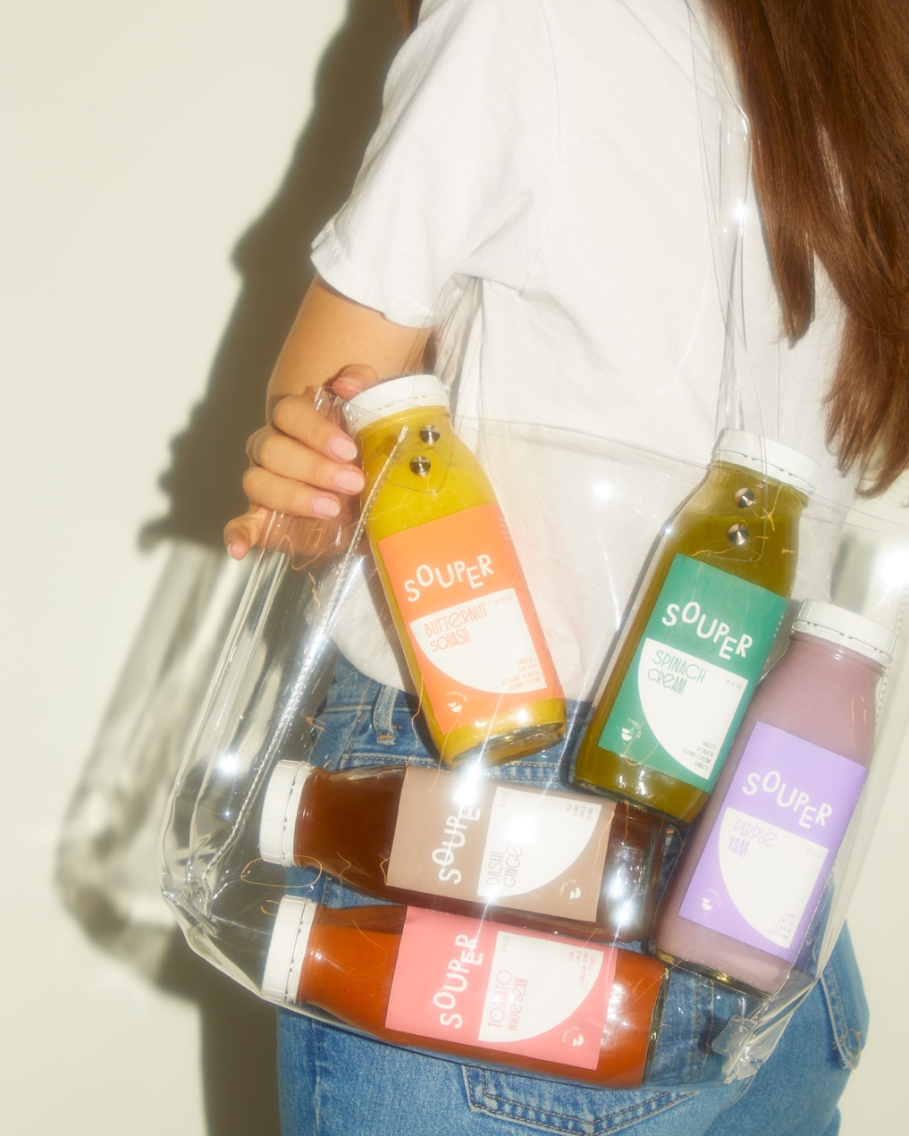

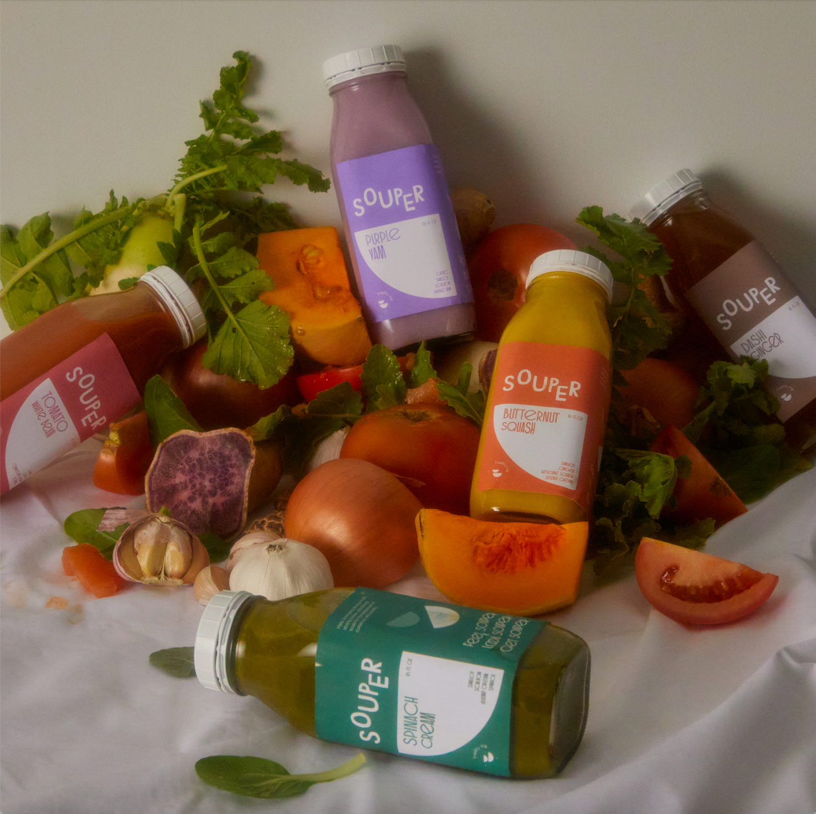

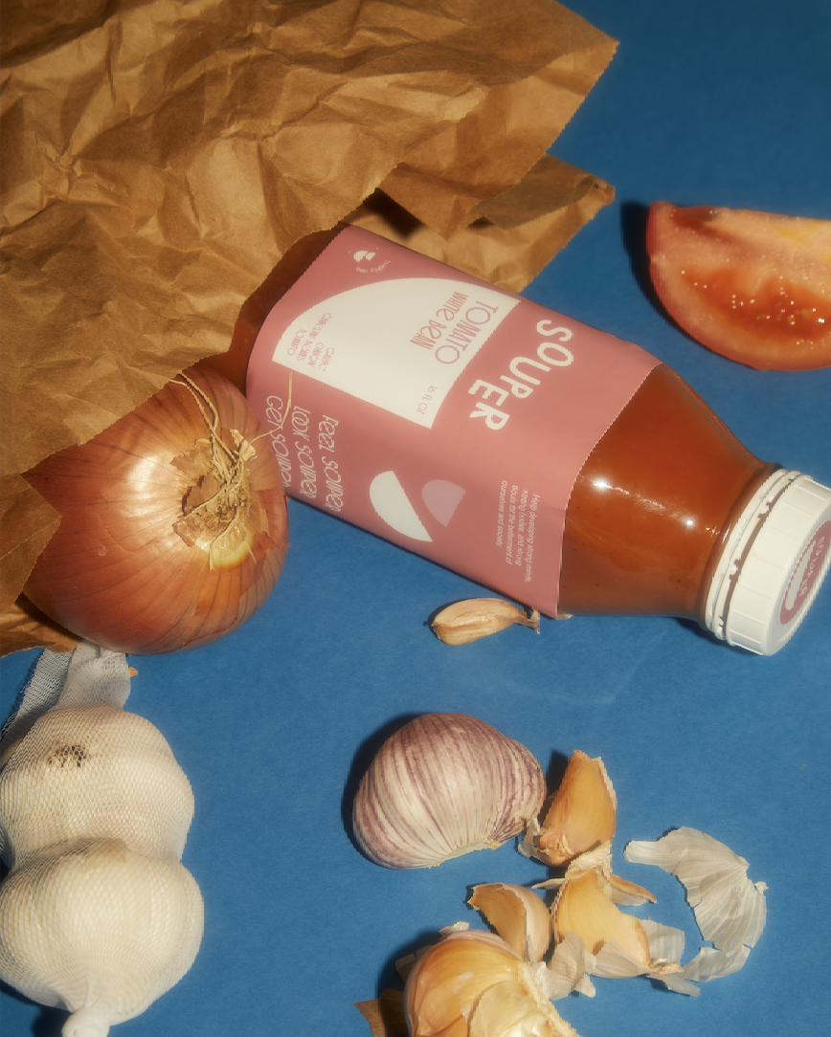

Contact: Marty Snyder

Co-founder

Email: [marty@getsouper.com](mailto:marty@getsouper.com)

Website: getsouper.com