FOR IMMEDIATE RELEASE
Monday, April 3, 2023
CONTACT:
Holly Jo Anderson
952-738-8177, ext. 700
holly@veritasmarketing.com



Birch Assist is now available on the GENESYS® AppFoundry

SEATTLE — BirchAI is pleased to announce that Birch Assist is now available on the Genesys® AppFoundry. AppFoundry is a marketplace of solutions that offers Genesys customers a curated selection of integrations and applications to help create great customer experiences. Birch Assist reduces average handle time (AHT) by up to 35 percent. It allows agents to focus on the customer and resolving the issue without worrying about note-taking.

“We are excited that Genesys Cloud customers can now integrate our state-of-the-art Birch Assist AI technology,” says Kevin Terrell, CEO and cofounder of BirchAI. “Together, we can advance next-generation automation solutions to rapidly increase efficiency and accuracy. Birch Assist is ideal for even the most complex contact centers such as insurance, banking and healthcare.”
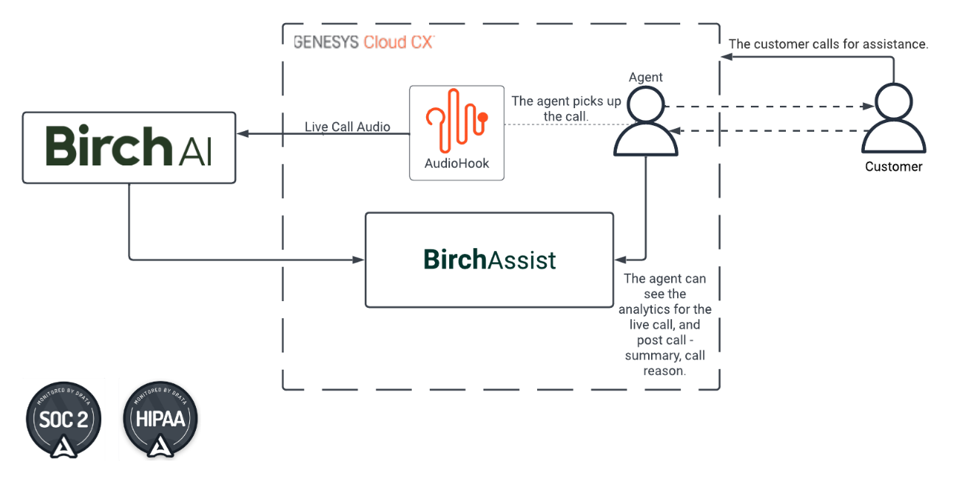

Birch Assist uses state-of-the-art natural language processing (NLP) technology to document a conversation in the call center’s record system within 15 seconds after call completion. The pre-filled category and summary is presented back to the agent who quickly reviews the information and moves on to the next call.

###
About Genesys
Every year, Genesys® orchestrates billions of remarkable customer experiences for organizations in more than 100 countries. Through the power of its cloud, digital and AI technologies, organizations can realize Experience as a Service®, the company’s vision for empathetic customer experiences at scale. With Genesys, organizations have the power to deliver proactive, predictive and hyper-personalized experiences to deepen their customer connection across every marketing, sales and service moment on any channel. It also improves employee productivity and engagement. By transforming back-office technology to a modern revenue velocity engine Genesys enables true intimacy at scale to foster customer trust and loyalty. www.genesys.com

About BirchAI
BirchAI is a leading AI platform for customer support. The company was founded by experts in the fields of natural language processing, enterprise adoption of AI and process improvement, and is backed by The Allen Institute for Artificial Intelligence, the country’s leading AI research organization. BirchAI focuses on advancing call center efficiency by automating resource-intensive aspects of customer care, including summarization, classification and analysis of customer calls. www.birch.ai

