FOR IMMEDIATE RELEASE

Thursday, May 25, 2023

CONTACT:

Holly Jo Anderson
+1 952.738.8177
holly@veritasmarketing.com

Multi-Wing introduces three new fans to exceed the demands of ever-changing airflow, noise and efficiency requirements
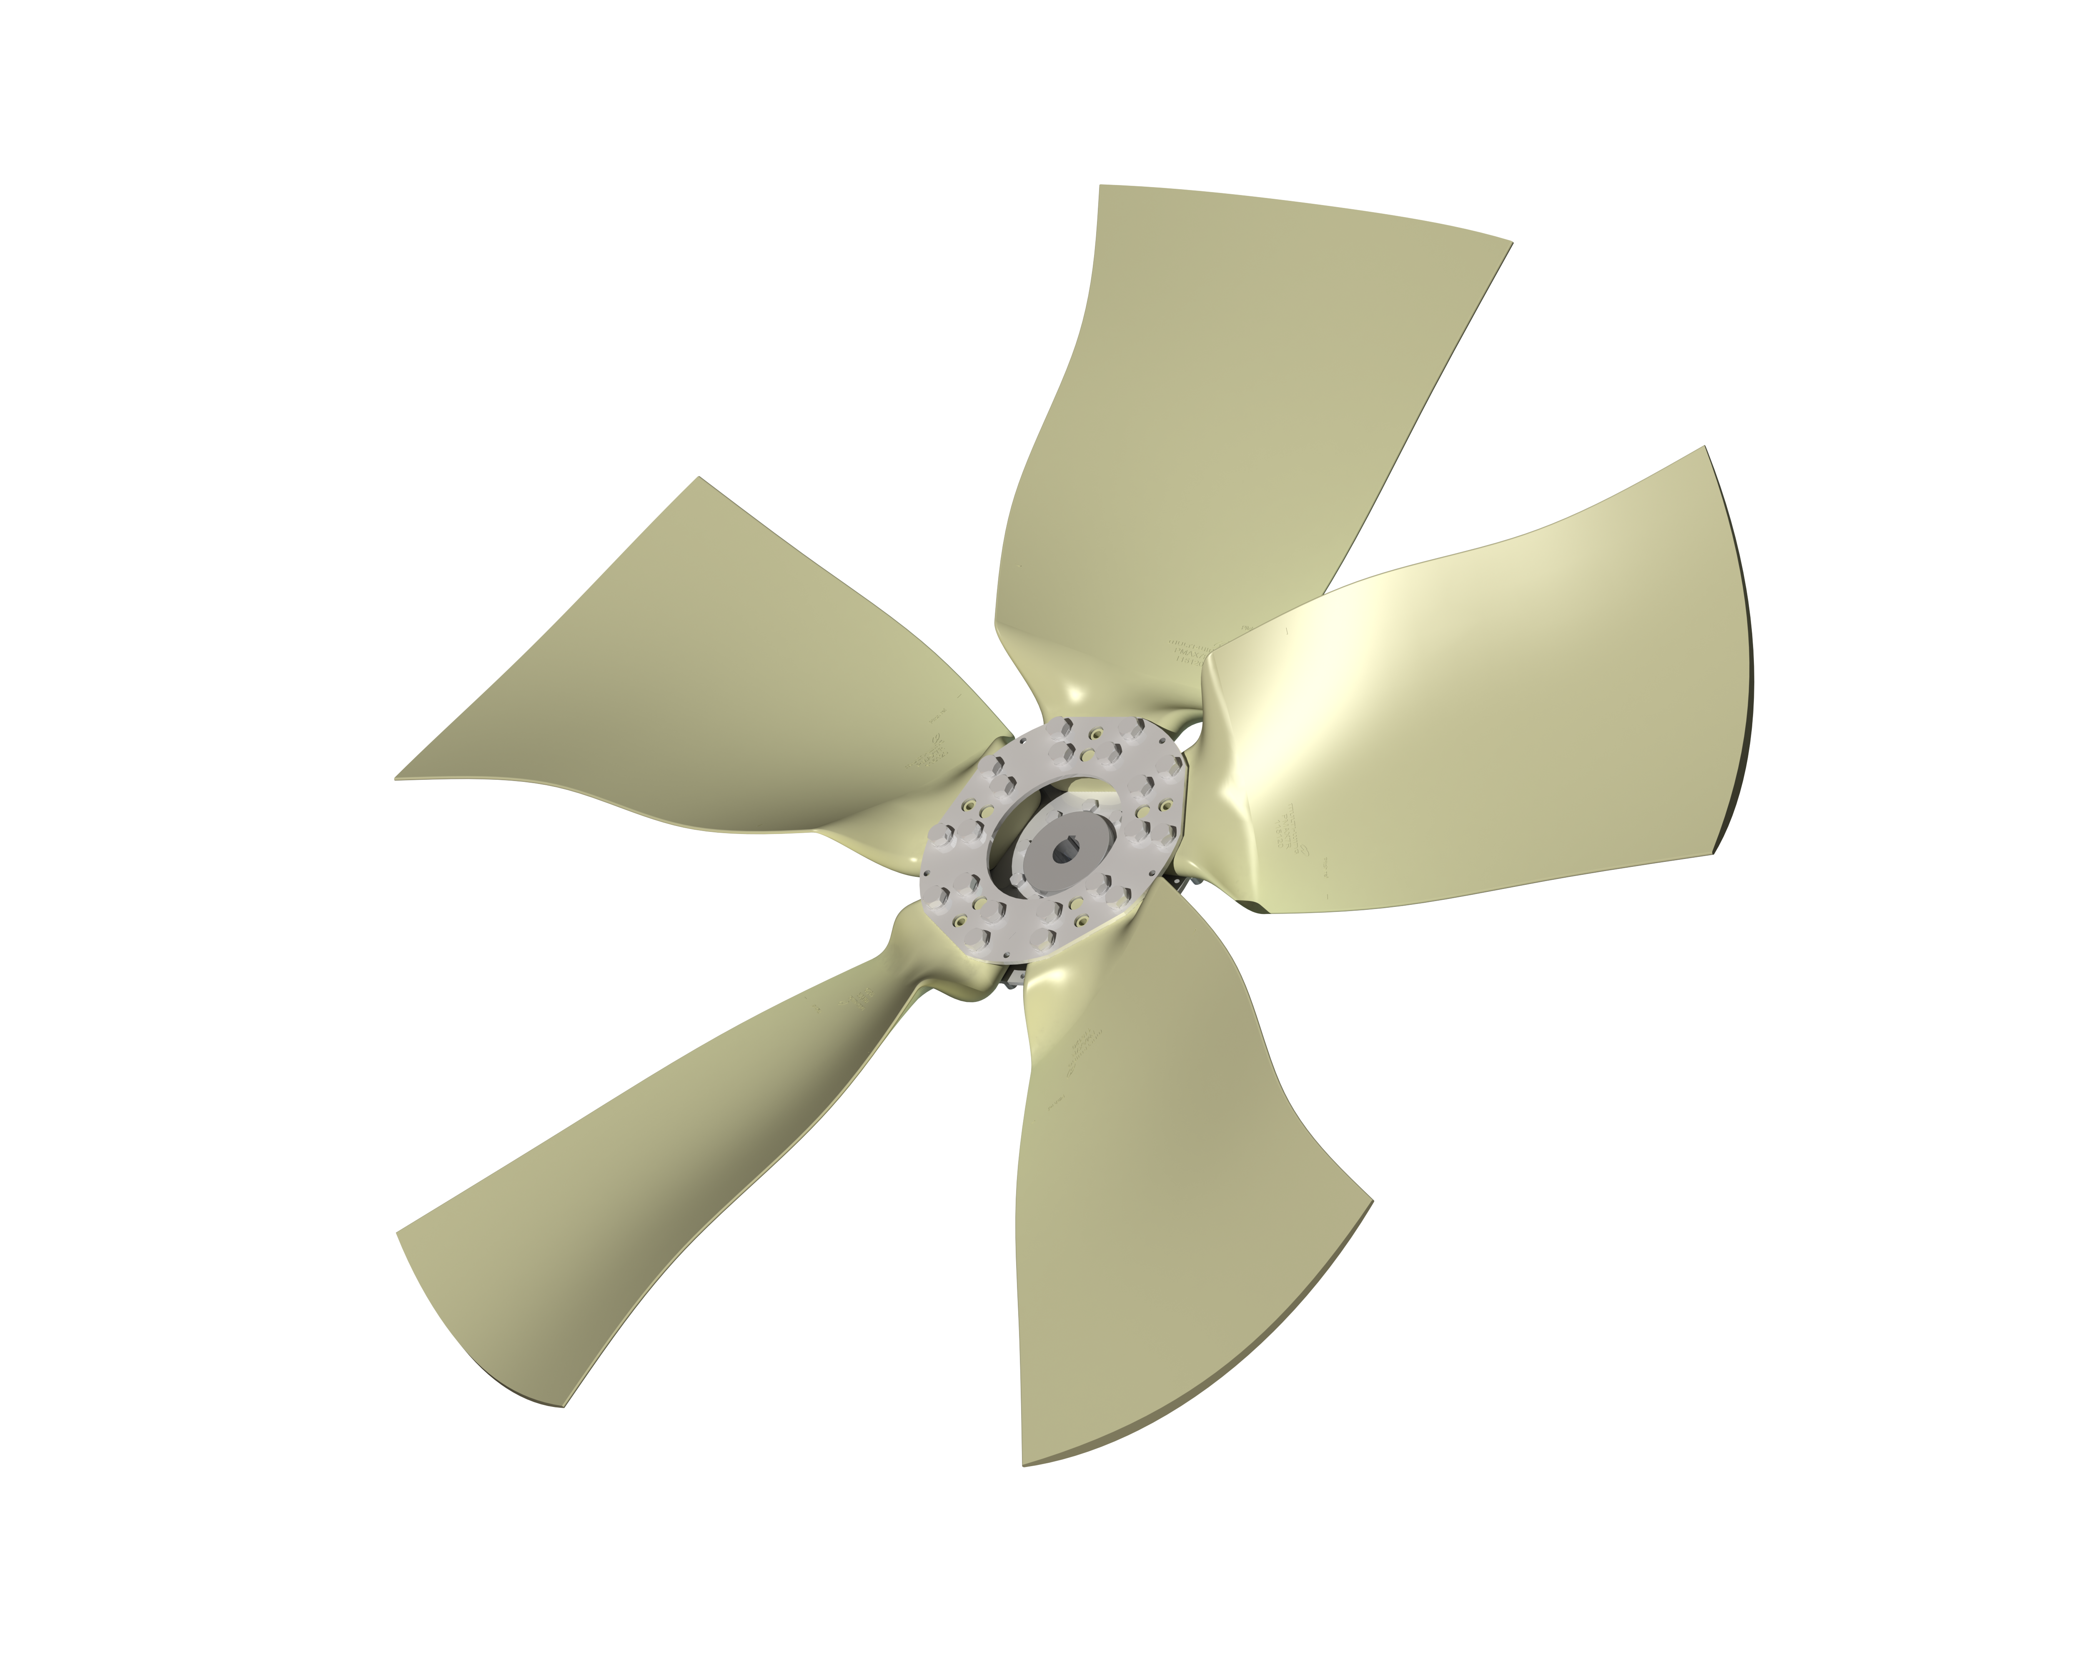
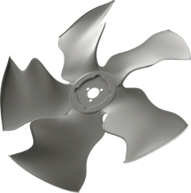
BURTON, Ohio — Multi-Wing is excited to introduce three new fan product lines: O-P1L, PMAX4 and PMAX7R. The O-P1L fan is engineered for emission-optimized engine cooling in a puller configuration for compact off-highway equipment. The modular PMAX4 fans feature aerodynamically optimized blades tailored to high-resistance engine cooling in a broad range of applications. The PMAX7R is designed for engine-cooling requirements in medium and large gensets, compressors and off-highway machinery.
O-P1L

“Our new fans are the next generation of modular fans, designed to exceed the demands of ever-changing airflow, noise and efficiency requirements,” says Patrick Bold, global business development manager for Multi-Wing Group. “Our innovative products are backed by dedicated engineering support, prototyping and advanced manufacturing to deliver the right fan for your application, quickly.”

—MORE—

O-P1L
Engineered for durability with a unique blade geometry and winglets, the O-P1L reduces noise emissions and power consumption while providing improved efficiency. This fan is optimized to deliver high pressure in restricted spaces, making it ideal for backhoe loaders, skid steers, compact- and medium-sized tractors, and other construction equipment. It is available in blade diameters from 12.75 to 20 inches (324 to 508 mm) with operating speeds up to 3,870 rpm at 176°F (80°C). Lightweight, stackable and affordable, O-P1L is compatible with Multi-Wing’s BM20 viscous clutch and is offered in a flange-mount version for high-volume orders.

PMAX4
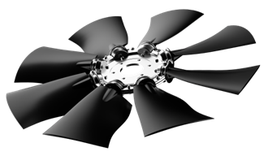
The PMAX4 has an aerodynamically optimized blade design and can be configured for a broad range of high-resistance engine cooling and other applications. PMAX4 delivers maximum efficiency and lower noise emissions over a wide operating range. It has a low axial width and is available in diameters from 20 to 33.66 inches (520 to 855 mm) with a larger diameter hub. The impeller’s blade stiffness minimizes deflection. PMAX4 delivers high airflow and static pressure for demanding cooling applications with high ambient temperatures. Extremely durable, PMAX4 achieves the same or better performance and greatly reduced noise emissions with a lower number of blades compared to competitive fans. It’s suitable for operating speeds up to 2,500 rpm at 68°F (20°C) at full blade length.
PMAX4

—MORE—

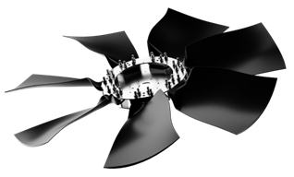
PMAX7R
PMAX7R
The new PMAX7R is ideal for medium- to large-gensets, compressors and off-highway machinery with challenging engine cooling requirements. The optimized modular blade design offers high efficiency with lower noise emissions while the strong and durable steel hub allows for customization without changing the blade geometry. PMAX7R can be configured
for maximum performance with 26°, 31° or 36° pitch angles.

To discuss your specific application with one of our engineering support specialists or to learn about PMAX7 fans, visit www.multi-wing.com/us/intro, call +1 440.834.9400. For access to our OPTIMISER fan selection application, visit www.multi-wing.com/us/optimiser.

Multi-Wing Group
Multi-Wing Group was established in the United States, Canada and Mexico in 1972 as Multi-Wing America. Headquartered in Middlefield, Ohio, Multi-Wing America is North America’s leading supplier of high-performance, modular axial fans in the broadest range of materials and blade profiles. Multi-Wing America is ISO 9001:2015 and 14001:2004 certified.

###

Multi-Wing America
+1 440.834.9400
info@multi-wing.net
www.multi-wing.com/us/intro

