FOR IMMEDIATE RELEASE
Wednesday, August 23, 2023
CONTACT:
Holly Jo Anderson
952-738-8177, ext. 700
holly@veritasmarketing.com

BirchAI achieves SOC 2 Type II Compliance for enterprise-level security
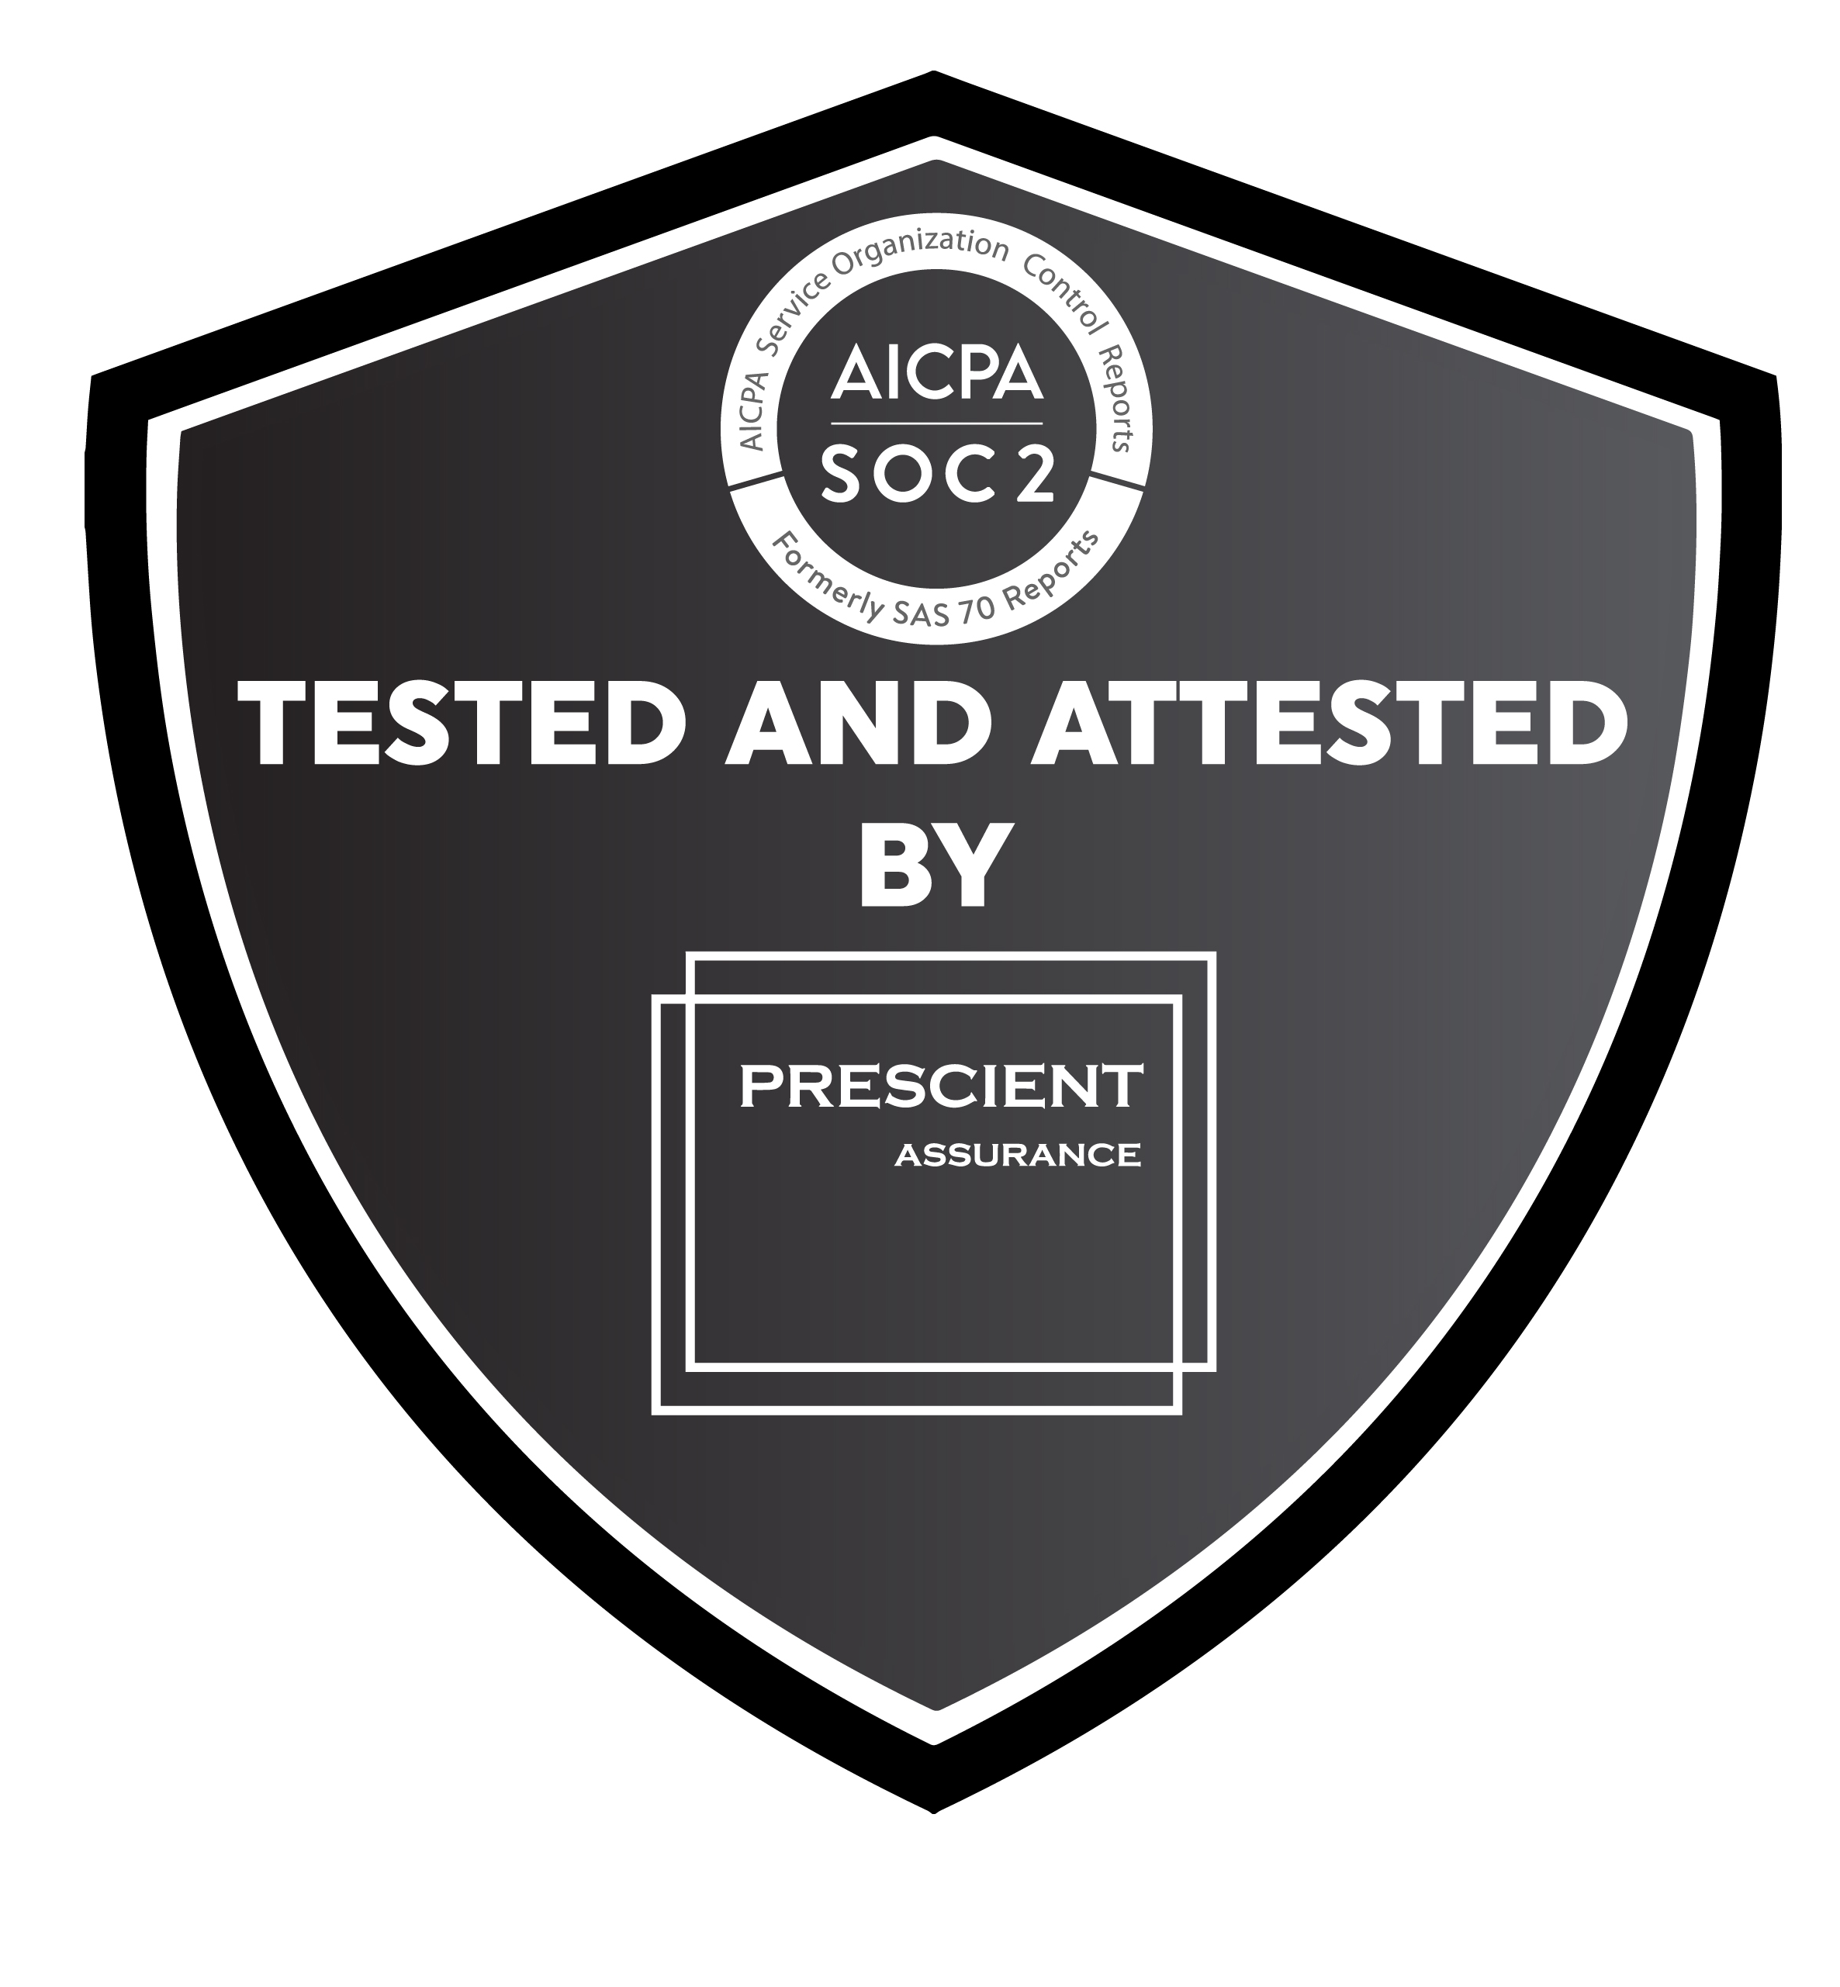
SEATTLE — BirchAI announced today that it has achieved SOC 2 Type II compliance in accordance with American Institute of Certified Public Accountants (AICPA) standards for SOC for Service Organizations also known as SSAE 18. Achieving this standard with an unqualified opinion serves as third-party industry validation that BirchAI provides enterprise-level security for customers’ data secured in the BirchAI System.

BirchAI’s generative AI technology allows agents to focus on the customer and resolving the issue without worrying about note taking—even for lengthy, complex calls in high-compliance industries like healthcare, insurance and finance. Documented in the call center’s record system within 15 seconds after a call, the prefilled category and summary is presented back to the agent. The agent reviews information and moves on to the next call. BirchAI’s automated documentation is highly accurate and reduces average after-call work (ACW) by up to 75 percent.

“This is an important achievement for BirchAI,” says Kevin Terrell, CEO and cofounder of BirchAI. “An unqualified opinion on a SOC 2 Type II audit report demonstrates to our current and future customers that they manage their data with the highest standard of security and compliance.”

BirchAI was audited by Prescient Assurance, a leader in security and compliance attestation for B2B, SaaS (Software as a Service) companies worldwide. Prescient Assurance is a registered public accounting firm in the United States and Canada and provides risk management and assurance services, which include but are not limited to, SOC 2, PCI, ISO, NIST, GDPR, CCPA, HIPAA and CSA STAR. For more information about Prescient Assurance, you may contact them at info@prescientassurance.com.

About BirchAI
BirchAI is a leading generative AI platform for customer support. The company was founded by experts in the fields of natural language processing, enterprise adoption of AI and process improvement, and is backed by The Allen Institute for Artificial Intelligence, one of the country’s leading AI research organizations. BirchAI focuses on advancing call center efficiency by automating resource-intensive aspects of customer care, including summarization, classification and analysis of customer calls. www.birch.ai

