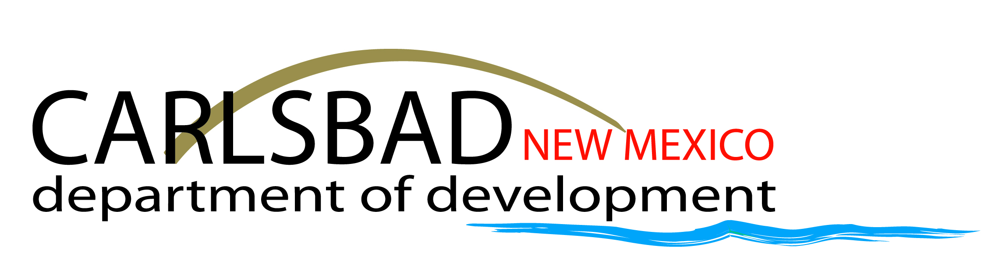
For Immediate Release

Carlsbad Department of Development Recognized for Excellence Once Again as Certified Economic Development Organization
Carlsbad, NM, September 2023 – New Mexico Economic Development Department announced recently that seven prior and four new community-based Economic Development Organizations (EDOs) around the state have been recognized for state certification by providing a high level of expertise and technical support to their communities. The Carlsbad Department of Development (CDOD) was among the seven prior organizations recognized for this designation.
Economic Development Deputy Cabinet Secretary Jon Clark announced the renewal of seven and the addition of four more Certified EDO awardees at the New Mexico Governor’s Statewide Conference on Economic Development, September 11-12. The certification can be renewed for up to a total of 10 years, with each organization eligible for up to $40,000 annually, depending upon annual recertification and availability of funding. This is the second year that the CDOD has received this certification.
CDOD President, Ericka Laney said, “The CDOD team works diligently to provide Carlsbad and Eddy County with some spectacular things. The recognition of becoming certified for the second year by NMEDD is a great honor, and testament of the Department’s hard work. I am excited for the future as we continue to help Carlsbad grow and thrive together.”
The CDOD strives to serve Carlsbad and Eddy County, New Mexico with excellence as the economic development agency for both. A variety of services are offered for community betterment, such as site selection, business planning, new business development, housing development, workforce recruitment and more. The companies served are in various industries showcased in Carlsbad’s diversified portfolio, including oil and gas, nuclear, potash, healthcare, manufacturing, and aviation industries.
“Carlsbad is the fastest growing city in the state and the Carlsbad Department of Development plays a vital role in assisting our key industries with site selection, recruitment and a host of other services,” said Carlsbad Mayor Dale Janway. “We are all committed to being the most business-friendly community in the state.”
The NMEDD recognizes its partner EDOs that provide a high level of professional excellence to their communities. Through the Certified EDO program, NMEDD supports communities like Carlsbad by helping the CDOD further its economic development services by building up the organization’s capacity. The program emphasizes the importance of being a strong community minded EDO, and being well rounded and well prepared in all aspects that pertain to their specific community.
Eddy County Manager, Roberta Gonzales commented, “This is a wonderful accomplishment and shows the dedication and hard work the Carlsbad Department of Development puts into the Community.”
Carlsbad has seen exponential growth in the last decade with the last few years showing huge results. The CDOD will continue to showcase Carlsbad to potential businesses as well as problem solve any challenges the growing community may face. With multiple projects in final stages and others just beginning, it is clear Carlsbad and Eddy County are preparing for future growth moving forward.

The Carlsbad Department of Development is the economic development agency for the City of Carlsbad and Eddy County, New Mexico.

#####

For additional information regarding this release
Carlsbad Department of Development / News Division
Office: 575-887-6562
Email: jeff.campbell@developcarlsbad.org
Web: www.DevelopCarlsbad.org

